- IELTS teacher training workshop with British Council+ DISKILL 3D interior design courses
In my perception of things, it's impossible to evolve by standing in one place. Since I worked mainly in the field of education as an English teacher, I considered it necessary for my professional growth to develop in another direction of language learning, going beyond the Belarusian format exams.

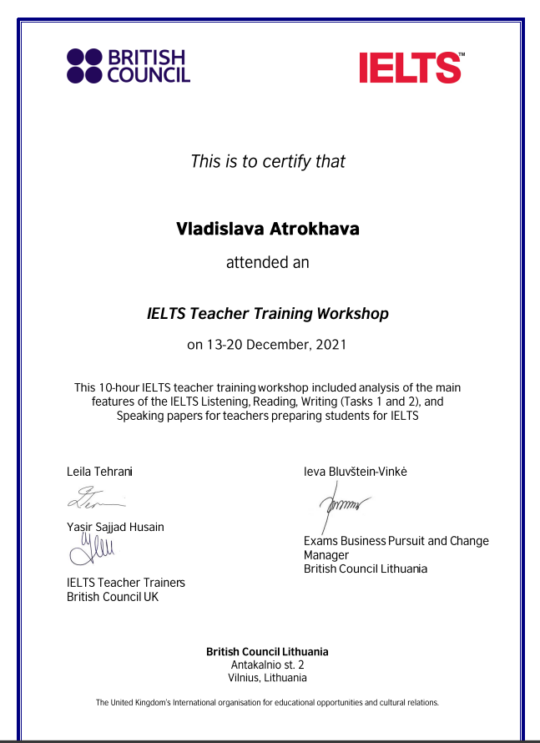

Moreover, I’ve never wanted to limit myself to just one field of endeavor. I have found peace and motivation in learning new and unfathomable things that I have never experienced before.
From time to time, I think it's important to challenge yourself and try something that is polar opposite to what you are doing. That was the key reason why I started interior design courses.


