Environmental project “Live Flowers Instead of Plastic Flowers”

The problem of plastic flowers which are brought annually in a large amount to cemeteries is a huge problem in our region.

In 2023 I was the initiator and organizer of the project for the sale of arrangements of fresh flowers in Minsk on Radonitsa. So I bought some natural season flowers from the local gardeners and composed them into flowers compositions, like small beds which was easy to transplant into open ground on graves. These compositions were available to purchase at very modest price in my personal accounts in Facebook and Instagram, and also I spent some time selling these compositions, and doing awareness-raising in person at the places near to the Minsk Church of Pantanassa God Mother icon and at the entrance of North cemetery of Minsk witch is one of the largest in the city.

Link to the post on Facebook:
https://www.facebook.com/login/?next=https%3A%2F%2Fwww.facebook.com%2Fstory.php%3Fstory_fbid%3D6165677773474984%26id%3D100000984674374%26mibextid%3DNoJtEM%26rdid%3DMjOf7tITQ1xxVvZF%26share_url%3Dhttps%253A%252F%252Fwww.facebook.com%252Fshare%252Fp%252FayYDAPfNqshocish%252F%253Fmibextid%253DNoJtEM&rdid=MjOf7tITQ1xxVvZF

The article mentioning the project on the environmental resource “Men and Creation”:
https://tvorenie.by/novosti/ekologicheskie-initsiativy-na-radonitsu

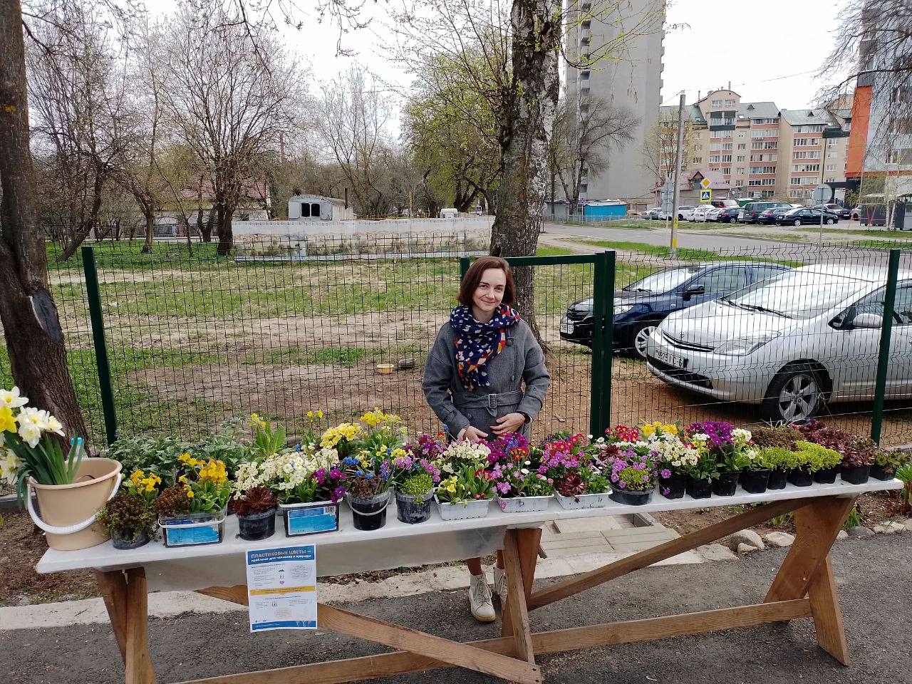
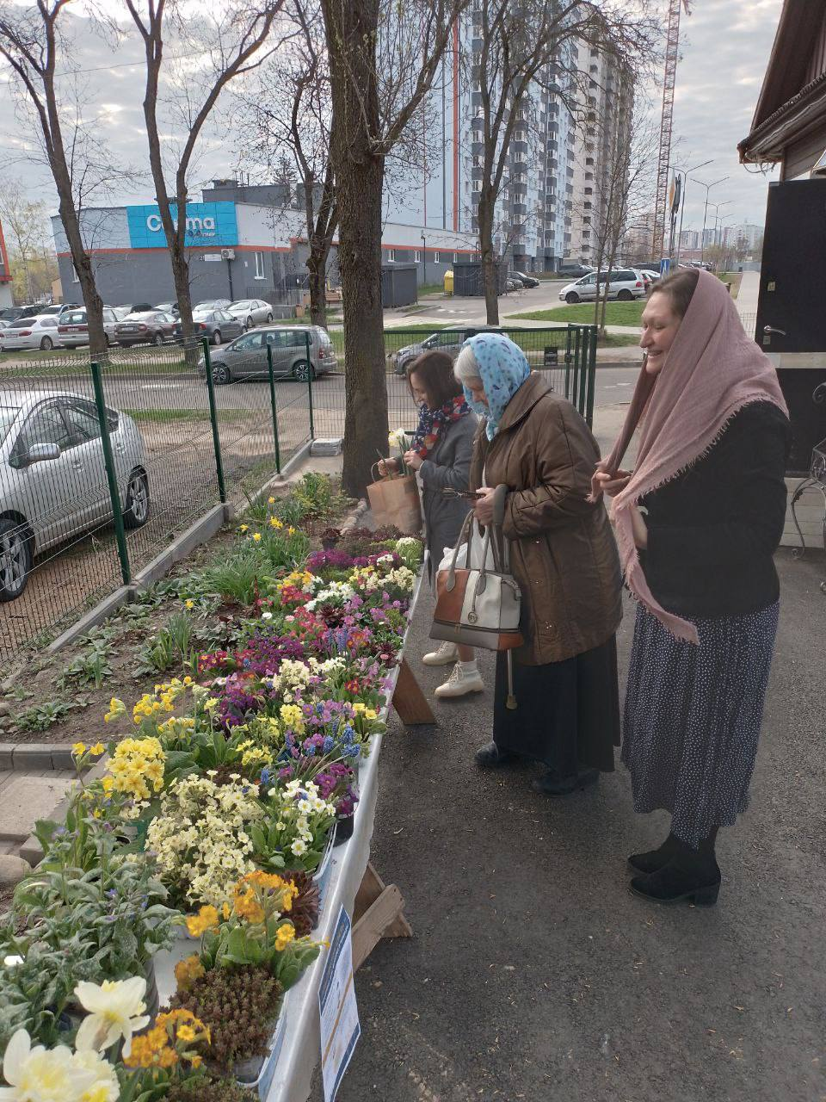 | 

