Creative works — Vladimir Omelin

Photography
My photos have been published by several media outlets, including National Geographic Russia, as well as NGOs such as the World Wide Fund for Nature (WWF). Here are a few of my photos that have received numerous accolades.
- Winner of the ‘The most beautiful country’ contest, the biggest photo contest in Russia.
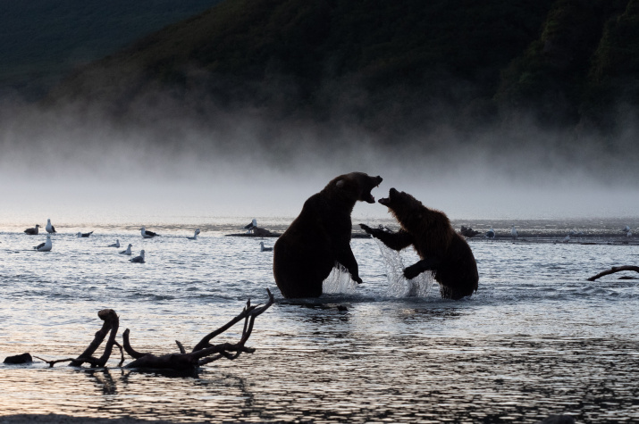

- Finalist of the 'The Most Beautiful Country' contest, the biggest photo contest in Russia. Photo was presented at several exhibitions.
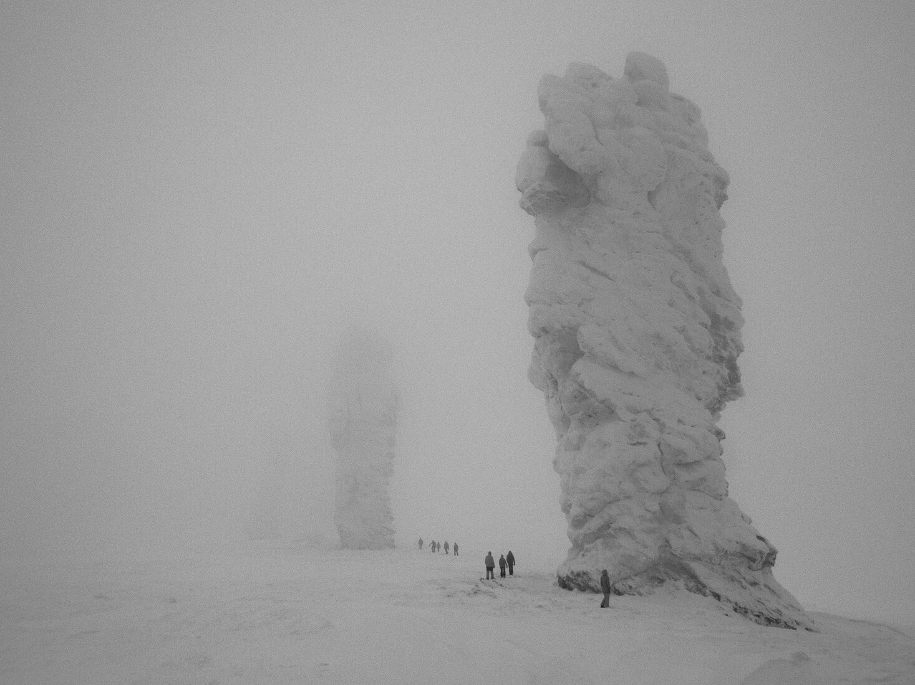

- Winner of the ‘Moya Planeta’ TV channel yearly photo contest. Photo was presented at several exhibitions.
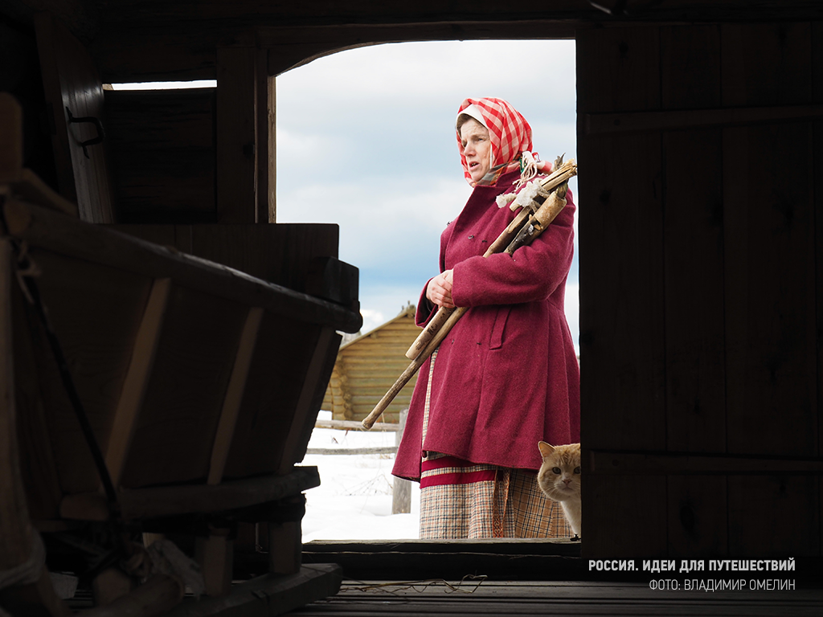

- This photo was presented at ‘Pristine Russia’, one of the most prestigious wildlife photo exhibitions in Russia.
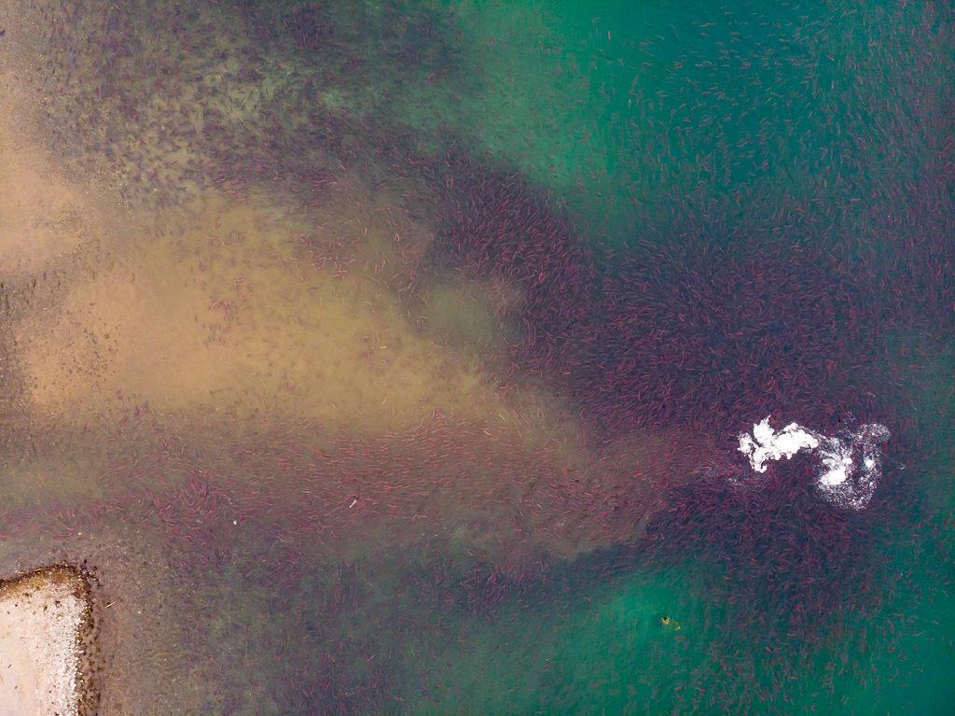

Wildlife documentaries
- Not only did I engage in wildlife photography, but I also worked as a director's assistant for the 'Sockeye Salmon: Red Fish' wildlife-saving documentary. The film was showcased at 170 festivals in 50 countries and received more than 80 awards.
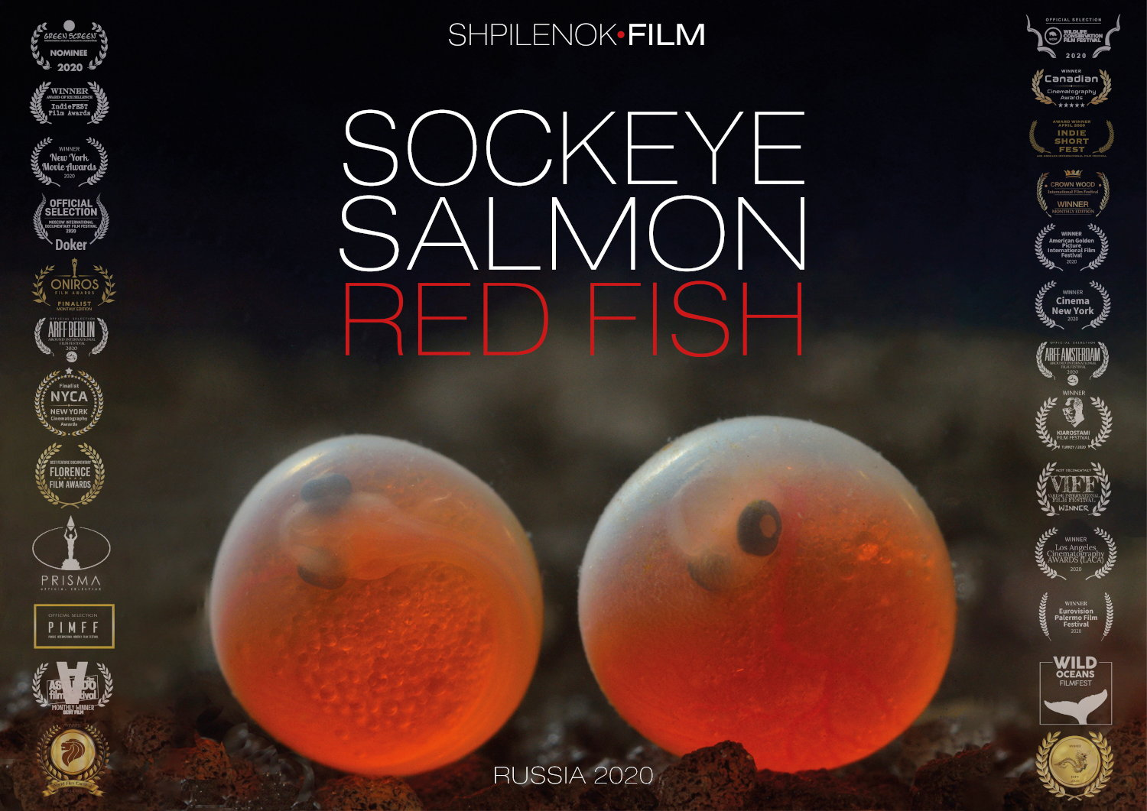
- Another wildlife-saving documentary I'm currently involved in as a screenwriter and editor is 'The Ancient Forest,' a documentary highlighting the immense importance of untouched forests that cannot be restored if lost. As part of the project, in 2021, I launched an independent media platform focused on the ancient forest as the Chief Editor.
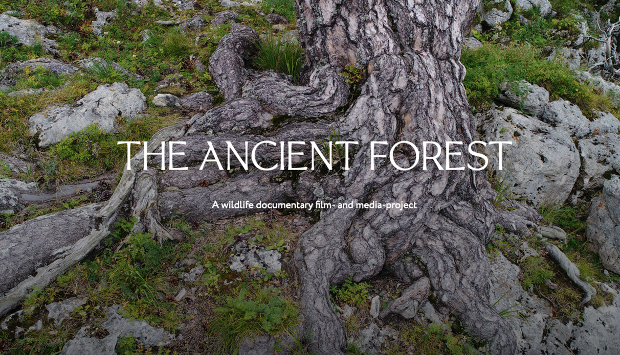

Writing, poetry, literary translation
Even though I have never considered myself a professional fiction writer, I have always had a passion for writing. I enjoy crafting short stories, poetry, and have even dabbled in literary translation. I have won a couple of poetry contests, one of which led me to London back in 2013, as well as several writing contests and the 'Reading Petersburg' (Читающий Петербург) translators contest. Some of my stories have been published in independent media outlets like Discours, while others have been featured in print publications, such as the short story for kids shown in the photo below.


