
List of achievements:
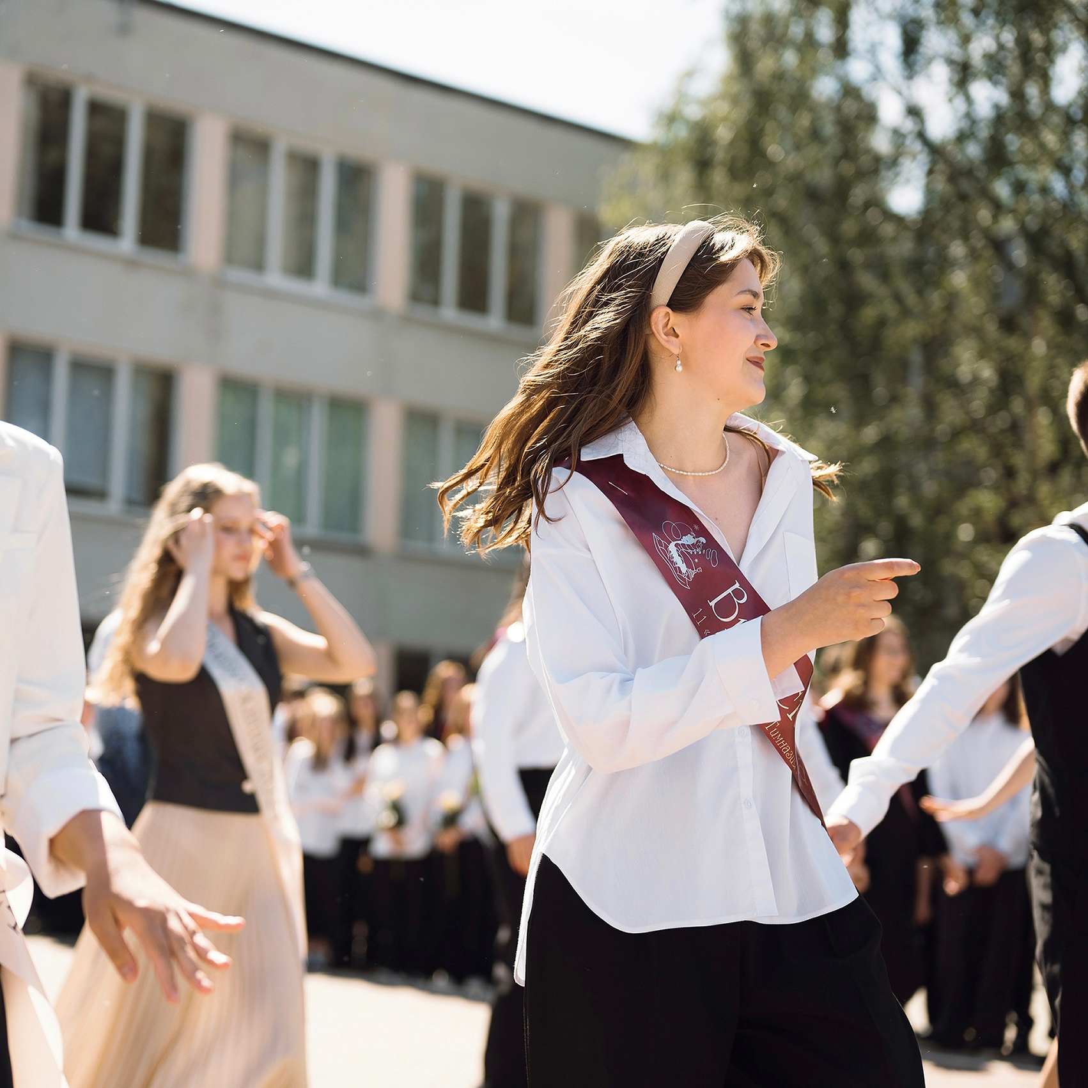

A) Creating advertising videos on Tiktok for Oz.by ( ООО "Приносим радость");
https://vm.tiktok.com/ZMr67L32Y/
https://vm.tiktok.com/ZMrMj28uY/
https://vm.tiktok.com/ZMrMjkJkN/
B) Shooting, editing, making scripts and video ideas for TikTok with results such as 20,000 subscribers, as well as 80K-400K views;
https://vm.tiktok.com/ZMrMjAfp7/
https://vm.tiktok.com/ZMrMjyg6P/
https://vm.tiktok.com/ZMrMjy567/
C) Founding and management of a non-commercial book club for more than 1 year (to date), including lecturing and creation of promotional videos for club: https://vm.tiktok.com/ZMrMjf37o/
(also i did a small video with the moments of our meetings: book_club_lebedeva.mov)
D) I take interest in mobile photography and photo editing (pictures are in file «photos_examples_lebedeva.docx);
E) Copywriting, content creator for my telagram-channel about psychology, books and my life experiences; https://t.me/theoryofeverythingy
F) Creating an online second-hand store «Second chance»; https://www.instagram.com/second.chance.minsk?igsh=MXdzanMweWJ1c29teA==
G) Participation in the youth self-development project "To be" as a speaker in social media marketing sphere; https://www.instagram.com/p/CmMpttmt9dM/?igsh=cXJheXpvaWs2Zmxn
H) Working as an smm-specialist, content development (photo processing, editing, design) on Instagram;
I) The establishment of a special tutor programm in popular psychology and spirituality;
J) B1+ english level;
K) Participation in the youth self-development project "To be" as a speaker on content creation and social media marketing; https://www.instagram.com/p/CmMpttmt9dM/?igsh=cXJheXpvaWs2Zmxn
L) Participation in academic competitions in belarusian language and literature, russian language and literature, english language, world history and geography (school, district, and city stages; unfortunately, many diplomas are lost, i attached the ones I have);
M)Participation in season games "Great British Quiz" with the result “Diploma of the second degree”;
N) Laureate of diplomas in the city intellectual competition «IC-game» in english language from the Institute for Education Development (MGIRO);
O) Conducting workshops focused on personal growth, soft-skill development and time management.
P) Organizing themed picnics: 1) Modern literature reading picnic + bookcrossing; 2) Tools for SMM development and networking
Q) Creating themed presentations for the book club.
There are my social networks, I will be glad if you visit them. https://www.instagram.com/pinkgrasss?igsh=MXF1NmtycDNld3ZteA==
https://www.tiktok.com/@lebedeva.av?_t=8nle3iamzTC&_r=1
Diplomas:
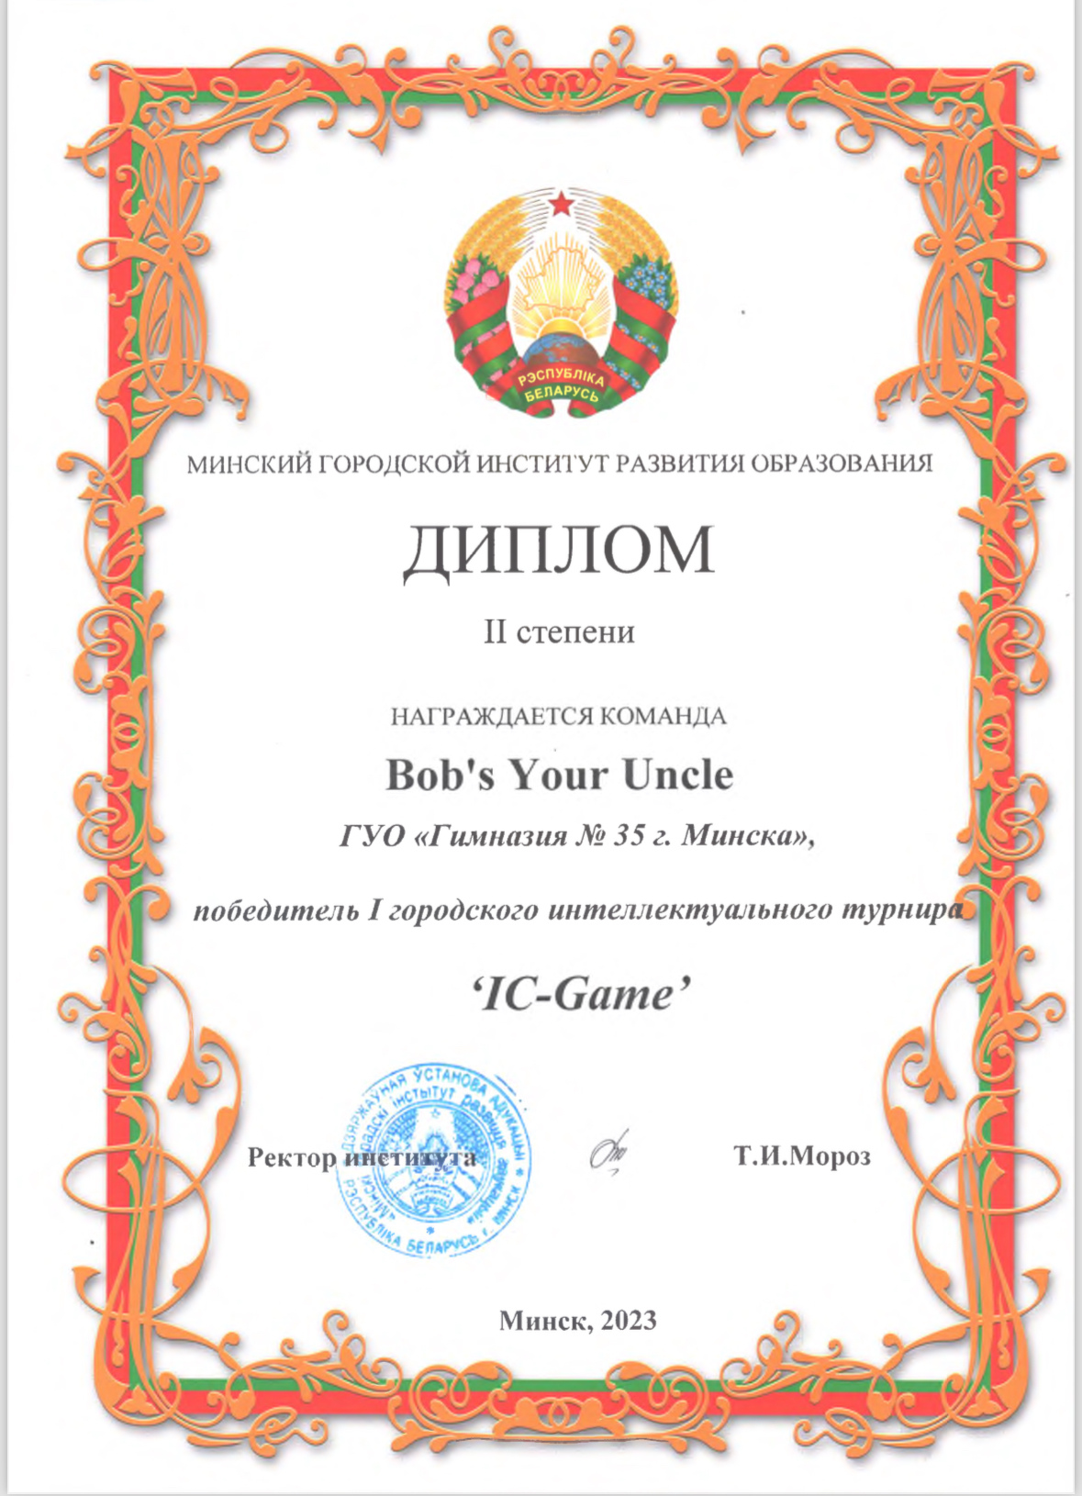

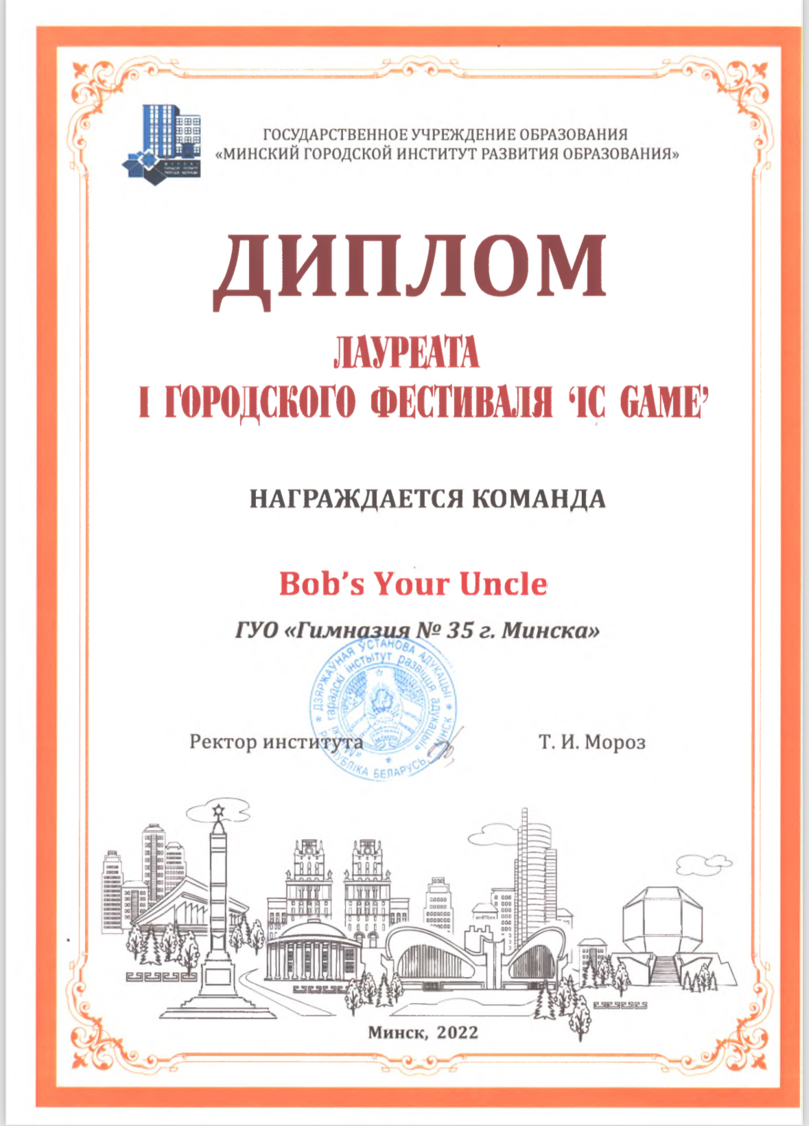
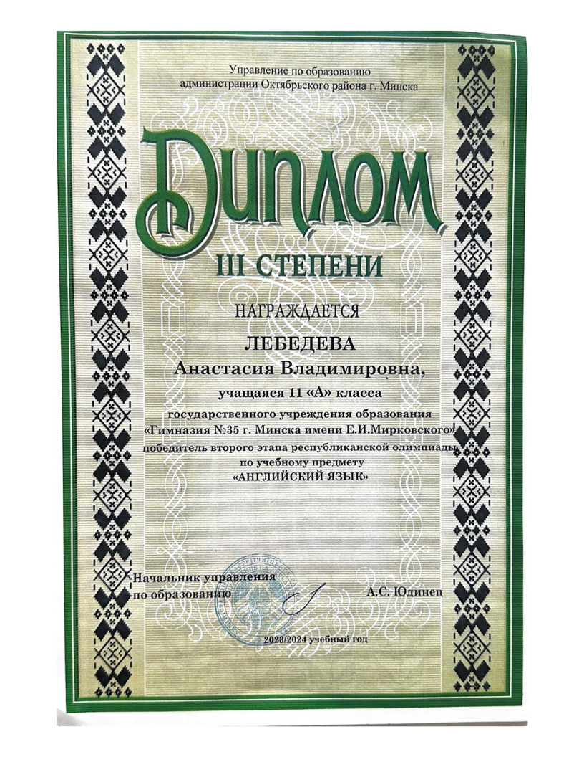
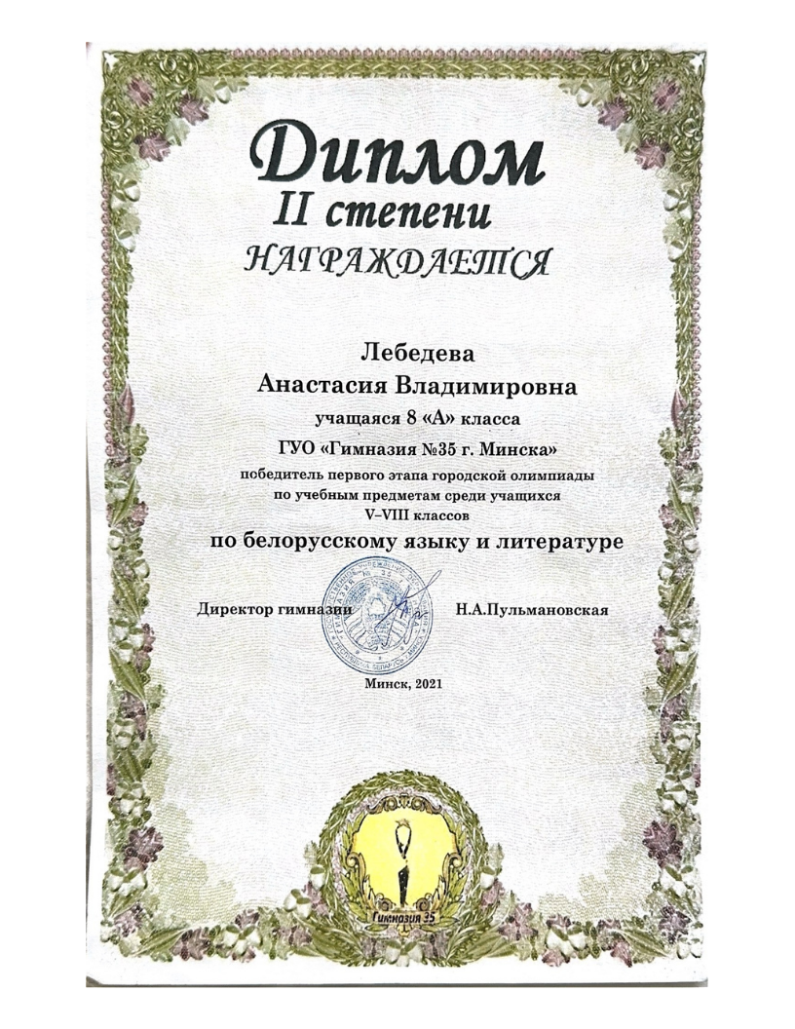
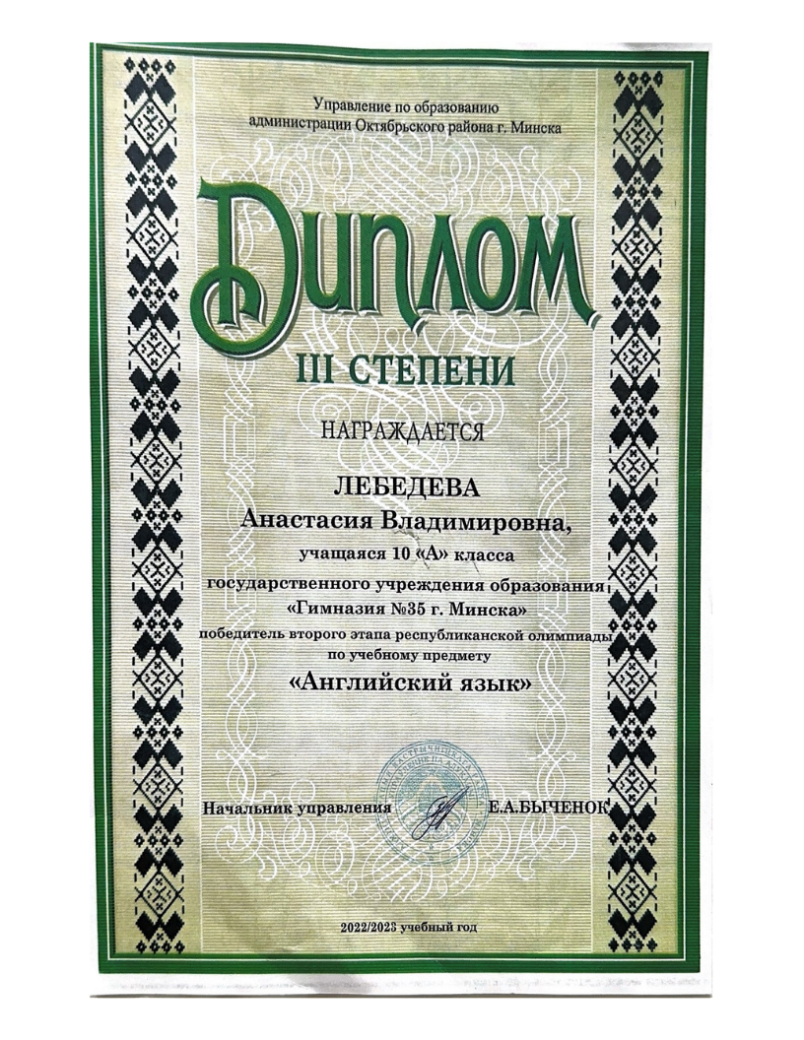
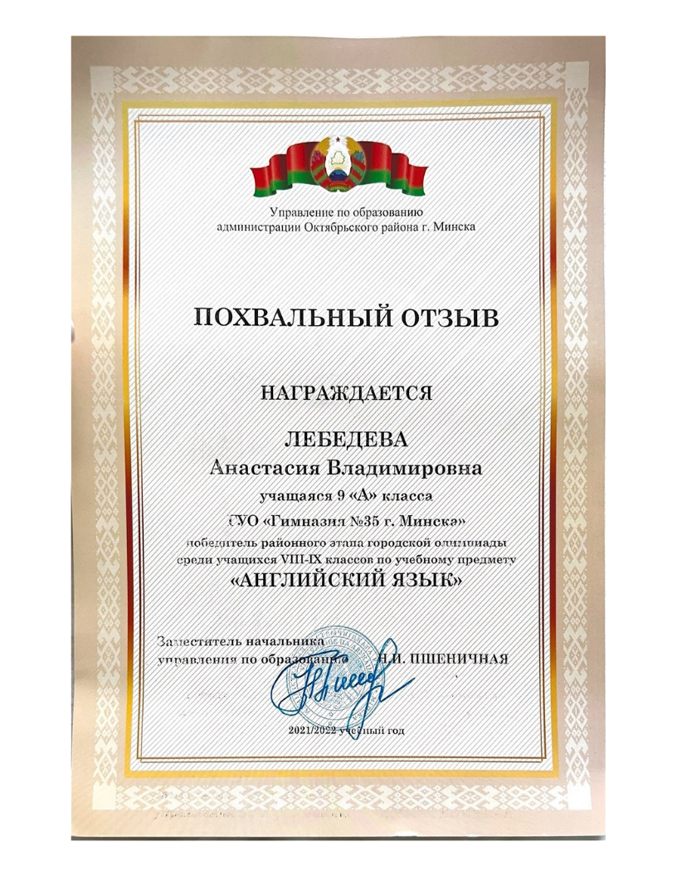
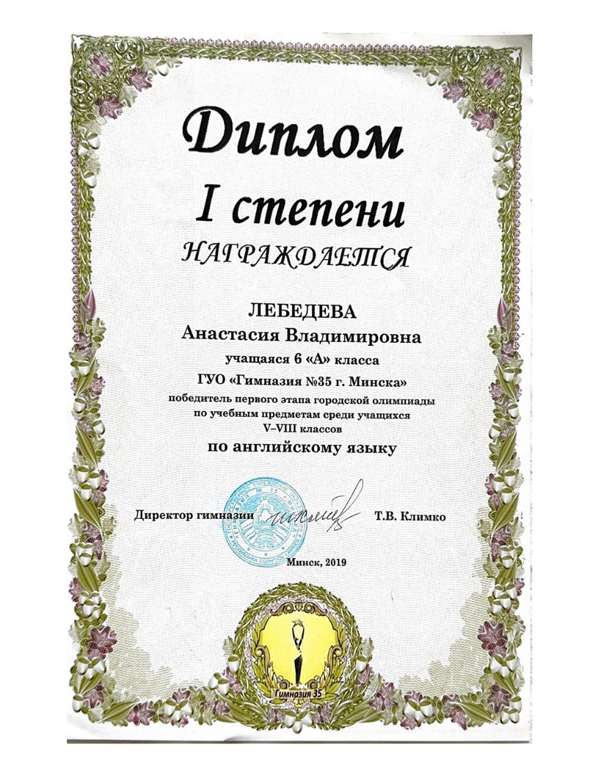
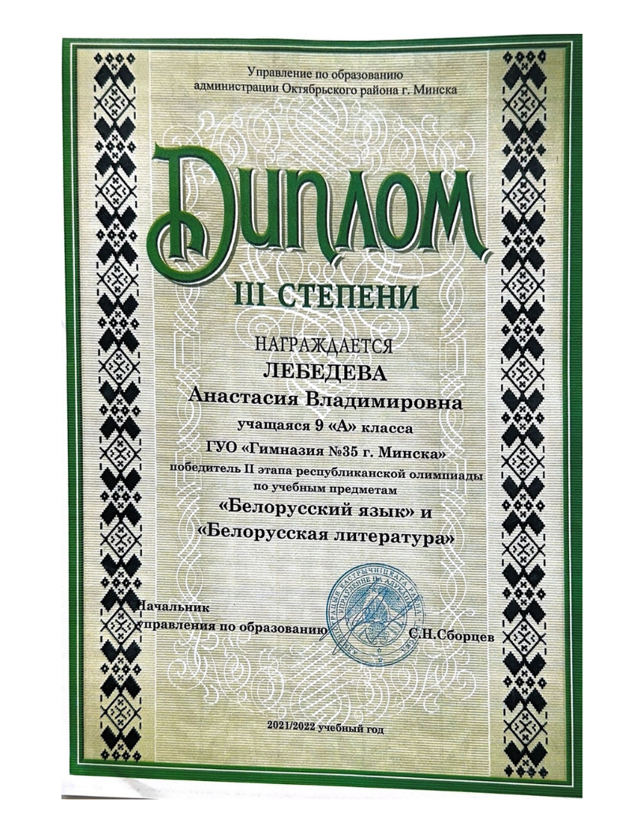
Thank you!

