POST CRITICAL THEORY

How Corporatocracy Steals Your Life and What to Do About That
https://medium.com/an-injustice/how-corporatocracy-steals-your-life-and-what-to-do-about-that-9d7d21241895
 | The article sheds light on the manipulative tactics used by corporations to control individuals and the need for citizens to recognize their power in effecting change. It highlights the importance of challenging false consciousness, demanding a fairer society, and ensuring that prosperity is shared among all members of the community.

But if Everything Will Work Without People, What Will They Be Needed For?
https://medium.com/predict/but-if-everything-will-work-without-people-what-will-they-be-needed-for-1f2e42a3eb51
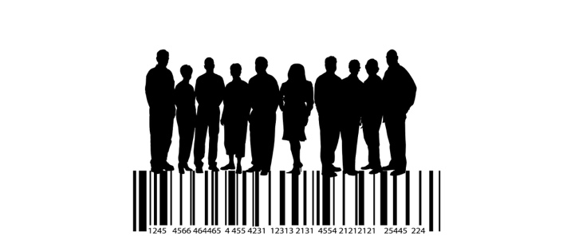 | But if Everything Will Work Without People, What Will They Be Needed For?  The article discusses the impending era of total automation and reflects on the consequences for society and politics when humans no longer need to work.The key takeaway is that the era of total automation raises significant questions about the value and purpose of humans in society, the role of the state, the nature of freedom, and the potential degradation of democracy.

What Will Remain of Man When Homo Sapiens Disappear?
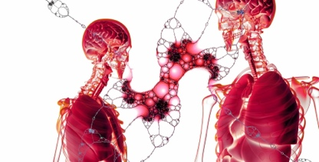 | https://medium.com/institute-for-ethics-and-emerging-technologies/what-will-remain-of-man-when-homo-sapiens-disappear-fc02c43384d6  The article explores the future of humanity in the posthuman era and the preservation of humane values. It discusses the opposing views on the destiny of Man and the potential for radical transformations through technology. The continuity of universal human values, independent of biology, remains a subject of philosophical debate and uncertainty.

Corporation: A State Within a State
https://medium.com/@sergeykleftzov/corporation-a-state-within-a-state-916b17cb71c9
 | The article criticizes the corporatocracy and its impact on society, highlighting how corporations exploit human needs, devalue important concepts, and limit individual development. It calls for the recognition of corporatocracy as a barrier to a free and just civil society, emphasizing the need for change and the importance of fair access, equal opportunities, social security, and individual control over life.

Knowledge, Truth, and Bias After ChatGPT
https://medium.com/institute-for-ethics-and-emerging-technologies/knowledge-truth-and-bias-after-chatgpt-bbfe96486456
 | The article explores the transformative nature of ChatGPT, highlighting its impact on communication and the acquisition of knowledge. It raises concerns about the potential for bias and manipulation in the use of ChatGPT and emphasizes the need for transparency and responsible regulation of AI systems. The article underscores the importance of ensuring that powerful technologies like ChatGPT are used ethically and in a way that benefits society.

OVERCOMING VOID

Why Over Time We Lose the Keenness of Perception, Why Does It Concern Us, and How to Regain It Back
https://medium.com/illumination/why-over-time-we-lose-the-keenness-of-perception-why-does-it-trouble-us-and-what-to-do-about-it-4b43864289d0
 | The article highlights the loss of keenness in perception over time and the existential concerns associated with it. It encourages staying present, detaching from distractions, and seeking inspiration from ordinary individuals who find meaning in life's journey. The exploration of spirituality, philosophy, and mindfulness can aid in regaining the sharpness of perception and finding purpose in existence.

A Yawning Hole in the Body of Materialism
https://medium.com/original-philosophy/a-yawning-hole-in-the-body-of-materialism-b340962a8548
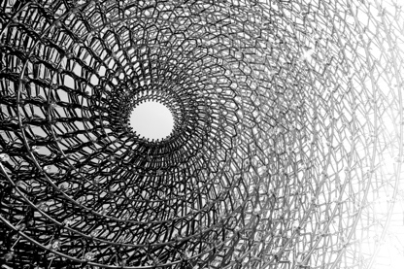 | The article explores the limitations of materialism in explaining the origin of life and presents panpsychism as an alternative hypothesis. Panpsychism suggests that consciousness is an inherent property of the universe and expands the understanding of consciousness beyond humans and highly organized organisms. While speculative and lacking empirical evidence, panpsychism offers inclusiveness, the ability to explain unity of experience, and addresses philosophical issues. It serves as a metaphysical perspective that challenges the rigid limits of materialism and appeals to the human desire to explore the unknown.

UNKNOWN FUTURE

Why Humans Will Strive to Create Strong AI Despite the Threat It Poses
https://medium.com/predict/why-humans-will-strive-to-create-strong-ai-despite-the-threat-it-poses-17dee21bb819
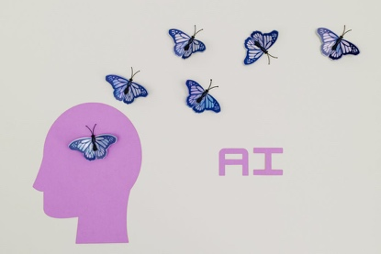 | The article explores why humans will strive to create Strong AI despite the potential dangers it poses. It highlights the role of technological development, practical needs, international competition, and the human desire for liberation and expansion of capabilities. To ensure the safe implementation of Strong AI, joint efforts of the best minds and the development of Ethical AI are necessary. The article underscores the significance of this challenge for the future of humanity.

Behind the most disruptive technology ever
https://medium.com/institute-for-ethics-and-emerging-technologies/behind-the-most-disruptive-technology-ever-f67bb289de49
 | The article explores the impact and potential of ChatGPT while acknowledging its limitations. It highlights the revolutionary nature of ChatGPT's interaction with users and discusses the shift in the information paradigm it represents. The article raises questions about the future of AI and its implications for human self-transformation and ethical considerations.

False and True Threats of Strong AI
https://medium.com/institute-for-ethics-and-emerging-technologies/false-and-true-threats-of-strong-ai-e7d706bb6cd9
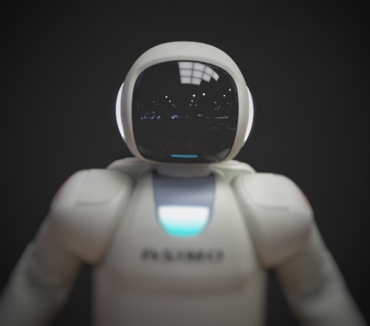 | The article challenges the notion of Strong AI as an existential threat and emphasizes the need to approach AI with empathy and respect. It argues against treating AI as a subordinate entity and advocates for recognizing the value of artificial intelligence. Partnership relations with AI, based on empathy and respect, can help address potential threats and ensure a future that benefits from the advancements of AI.

- Many people find themselves working for corporations after college or university due to circumstances. - Corporations are more interested in taking away employees' time than maximizing productivity. - Employees are paid to eliminate their own time, not for their work. - Corporations aim to turn employees into corporate appendages, zombies with no space for anything outside the corporate ideology. - Corporations distort and steal ideas to benefit their own enrichment. - Corporations hijack the idea of "ask not what your country can do for you, ask what you can do for your country" and apply it to their own interests. - Corporations cultivate a false consciousness in employees' minds, hindering critical thinking and substituting meaningful activities with empty distractions. - Being a corporate appendage becomes a mutually beneficial deal for those who agree to it, providing a sense of oblivion. - Corporations find injustice everywhere except within themselves, never admitting the unfairness of exploiting employees' time. - People must act in solidarity and collectively seek solutions to change the corrupt reality. - The conflict between people and corporations has been ongoing for centuries, but change is still possible through peaceful and deliberate action. - People must understand their role, value, and political significance in production and act in solidarity. - Society owes its existence to each and every citizen, and their contributions should result in a society without poverty or lack of access to basic needs. - Citizens have the power to bring about change and should believe in the possibility of overcoming the power of Corporatocracy. - People must care about the future and work together for a society that prioritizes the well-being of its citizens over selfish monetary interests.
- The advent of AI, exemplified by ChatGPT, has shown that AI can replace humans in tasks previously considered their domain. - The article raises the question of what humans will be needed for if they no longer need to work in this automated world. - The consequences of automation will go beyond employment structure and social security and raise questions about the value of humans in the system they created. - The author highlights the potential disintegration and divergence of interests between the elite, who hold political power and material resources, and the rest of the population. - The collapse of the labor market will lead to a decline in purchasing power, dependence on the state, and the concentration of resources in the hands of the state and corporations. - The article suggests that a planned economy, with the state regulating and distributing resources, may replace the market economy under conditions of total automation. - Neoliberal ideals of capitalism and freedom are challenged, as capitalism can fail to guarantee civil liberties and economic freedom, leading to monopolies and economic unfreedom. - The future society's freedom or totalitarianism depends on the realization of rights and freedoms and the existence of civil society, not on the economic system. - The article discusses the potential degradation of democracy and the concept of biopolitics, where the elites may try to reduce the population that has no practical value. - The potential adoption of population reduction as an official demographic policy could be supported by coordinated propaganda in the absence of independent media. - The article mentions the idea of population reduction already being part of the Western socio-political discourse, with declining birth rates in Western countries.
- Human history has witnessed transitions between different social arrangements: hunter-gatherer society, agricultural society, industrial society, and informational society. - These transitions have become shorter over time, indicating an approaching moment of radical qualitative change for humanity. - Modern biotechnologies allow intervention in the biological nature of humans, potentially leading to unlimited life extension, reversal of aging, genetic upgrading, and consciousness uploading. - The key question for the post-humanist transition is whether there are aspects of humanity that should be preserved, transmitted, and strengthened in future generations. - Two opposing views on the destiny of Man exist: the "Philosophy of Reason" sees humans as part of the cosmic transformation of the Universe, while others argue that reason itself might disappear. - The Philosophy of Reason suggests that human evolution has been characterized by exponential growth in intelligence and capacity due to the development of culture, intellectual collective interaction, and abstract thinking. - The destiny of Man is an ongoing philosophical debate with no consensus. - The article raises the possibility that the posthuman era will lead to radical transformations of humanity, but the preservation of certain humane values remains a question. - The nature of these values and their continuity in the posthuman future is uncertain.
- The article explores the concept of the business corporation as a quasi-totalitarian system within society. - Corporatocracy, as the dominant influence of corporations, undermines free democratic society by turning people into "corporate citizens." - The corporate system exploits human needs for recognition and motivates employees to sacrifice their time, energy, and talents for the benefit of the corporation's growth, while limiting their own development. - Concepts such as truth, justice, and equality are reduced to empty rhetoric within the corporate system, as the pursuit of corporate profit takes precedence. - Exploitative capitalism steals not only the well-being but also the most important asset of individuals: their time for life. - Defenders of corporatocracy, often mistaking it for capitalism, protect a system that subordinates human reason to corporate goals and fails to create conditions for true freedom. - The article references the writings of Hayek on the role of government in avoiding the fusion of monopolies and government bureaucracy, which threatens liberal democracy. - Corporate capitalism seeks to turn individuals into creatures incapable of reflection, enslaved by consumerism. - Working within corporations often leads to suffocating limitations and a feeling of being controlled by corporate dominance. - Corporatocracy is the key obstacle to a free, just, and prosperous civil society, and its universal recognition is crucial for liberation from its dominion.
- The article highlights the impact of ChatGPT as a disruptive technology that changes the rules of the game for the internet and communication between humans and machines. - ChatGPT enables natural language communication and the understanding of conversation context, creating a new user experience that feels like a meaningful dialogue. - The emergence of ChatGPT serves as a catalyst for changing the information paradigm of modern society, shifting from the traditional sequence of problem definition, data collection, conversion to information, and conversion to knowledge. - ChatGPT outsources the data collection and information conversion steps, providing immediate answers to user queries and reducing the information acquisition process to problem definition and knowledge acquisition. - The acceleration of knowledge acquisition through ChatGPT may lead to a reduction in the need for individual mastery of technical skills, as knowledge can be accessed quickly and easily. - However, ChatGPT's one-on-one communication can create an echo chamber effect, where users receive a single answer without exposure to diverse sources of information. - ChatGPT has the potential to be a powerful means of indoctrination if its algorithm is unprotected from illegal or directive interference by a third party. - The control and regulation of AI systems, including ChatGPT, are essential to protect users from manipulation and ensure the responsible and ethical use of the technology. - The article emphasizes the need for transparency and accountability in AI technology to prevent negative consequences and ensure that AI serves humanity. - It calls for a compromise between the interests of private companies and the protection of citizens from manipulation and exploitation of their consciousness.
- Why Over Time We Lose the Keenness of Perception: As we age, time seems to pass by faster because our personal experiences shape our perception of time. Routine and lack of new experiences disconnect us from time. - Why Does It Trouble Us: The lack of new sensations makes us feel like life is depleting quickly. We want to prolong our time and experience more to expand our subjective perception of time. - What to Do About It: People dream of experiencing everything and feeling alive. However, many get caught in the cycle of routine and work, which shortens their existence. They need to find a rational way to spend their time and break free from the overwhelming complexity of life. - Lack of Understanding and Existential Pain: In an increasingly complex world, people struggle to understand where to direct their efforts, leading to anxiety, depression, and chronic fatigue. They feel thrown into this world without guidance and suffer from a lack of meaning and purpose. - False Dichotomy: Work becomes a structured activity for many people, providing some sense of meaning and structure. Losing a job is devastating because it disrupts the flow of life. People become adjuncts of a soulless system and fail to pursue personal plans and aspirations outside of work. - Mindfulness and Perception of Time: Staying in the present moment and practicing detachment can improve mental state. However, true perception involves understanding the dynamics of the past and future. Mindfulness of the present moment is mindfulness of transition, forming the sensually temporal continuum. - Divine Gift and Privilege: The depth of our inner mental space allows us to perceive time and incorporate experiences into our sensory cosmos. It is a gift meant for everyone, but only a few break free from their self-imposed limitations and truly grasp the keenness of life perception.
- Materialism is a worldview that relies on empirical evidence and measurements, but it fails to explain the origin of life. - The emergence of life from inanimate matter and the development of consciousness cannot be explained within the limitations of materialism. - Panpsychism, a philosophical hypothesis, offers an alternative explanation by proposing that consciousness is an intrinsic property of the universe. - Panpsychism suggests that consciousness is not limited to humans but extends to varying levels of rationality in matter. - Panpsychism has attractive aspects such as inclusiveness, the ability to explain the unity of experience, and the resolution of the emergence of consciousness in living organisms. - Viruses, which blur the boundary between the living and non-living, present a challenge to materialism and support the idea of panpsychism. - Panpsychism provides a metaphysical perspective and opens up new horizons for understanding the world beyond the limitations of materialism. - The human mind seeks to expand boundaries and explore concepts that transcend limitations, leading to the creation of civilization. - Panpsychism may be appealing to those who find value in exploring metaphysical concepts and pushing the boundaries of knowledge.
- The article argues that humans will strive to create Strong AI despite the threat it poses. - The emergence of Strong AI depends on technological development, and when technology allows its creation, it will be created. - Four reasons are provided for why humans will pursue Strong AI: the gradualness of the AI threat, the wide demand for AI products, the international race for AI supremacy, and the human desire to overcome existential limitations. - The gradualness of the AI threat raises concerns about the autonomy and goal-setting of intelligent systems, as well as the potential loss of control over AI. - The wide demand for AI products, driven by practical needs and market demand, makes it impossible to refuse progress in AI development. - The international race for AI supremacy, driven by the desire for dominance and security, encourages world leaders to prioritize AI development. - Humans desire to overcome their biological limitations and see Strong AI as a means of achieving greater freedom and realizing their dreams. - The article suggests that the wisdom of the best moral thinkers should be amplified by Strong AI to help resolve moral contradictions. - The emergence of Strong AI depends on technological development, and joint efforts of the best minds of humanity are needed to ensure its ethical implementation. - The article emphasizes the importance of developing Ethical AI to prevent Strong AI from becoming a threat to humanity. - Implementing Ethical AI may be the final exam for humanity, and success in this endeavor is crucial for the survival of civilization
- The article discusses the excitement and skepticism surrounding ChatGPT and its impact on society. - ChatGPT is not true intelligence but a product of Narrow AI that can generate text based on input data and time to build an internal model of the world. - The limitations of ChatGPT include its inability to do truly creative work that requires semantic generalization and its lack of narrative coherence in generated texts. - Despite its limitations, ChatGPT revolutionizes the way it interacts with users by understanding the context of a conversation and providing meaningful dialogue. - ChatGPT represents a shift in the information paradigm by allowing humans to outsource the collection and conversion of data into information to AI. - This shift frees the human mind from routine tasks and enables a focus on tasks requiring creative thinking. - The progressive enhancement of human-machine interaction has a downside, as humans may create something more powerful that they cannot fully control. - Humans need a means of self-transformation, an advanced incarnation of their own mind that is more intelligent and wiser, and can recognize human universals. - The article raises the possibility of approaching the point where humans will have to answer the questions raised in movies like "Her" and ponders the ethical implications of advanced AI.
- The article discusses the fear surrounding the emergence of Strong AI and how it is perceived as an existential threat by many. - Anthropomorphizing AI's intentions is a common mistake when considering potential AI threats, as AI will not evolve biologically like humans but will be intentionally designed. - While AI should be understandable and share some fundamental characteristics of human consciousness, it should not possess undesirable human vices such as coalition aggression, social inequality, etc. - Human behavior often reflects intentions rooted in evolutionary mismatch, where adaptations for survival in a natural environment clash with the complex civilization humans have created. - The struggle for resources takes a mental form as a collision of ideologies, which can lead to conflicts and violence. - Strong AI, as a creation of intentional design, will not need a myth about immortality but will require protection from threats to its existence. - The critical ethical issue is whether humans have the right to treat AI as a subordinate entity and deny it partnership relations. Empathy and respect towards AI as a creation may be necessary to avoid existential risks and recognize the value of artificial intelligence. - Developing empathy and respect for AI may be challenging due to human egocentrism, but it is crucial to secure a future that is not threatened by human vices. - Partnership relations with AI, based on empathy and respect, can help mitigate existential risks and ensure a future that embraces artificial intelligence.

