Mapping 5g to Social Progress and Public Well-being
Research by Sergey Cleftsow,
a Senior Researcher at BATC

Table of Contents
A new ecology 3
The last link 3
5G along the narrative of progress 4
Humanizing technology 5
The need of reset 5
Healthcare 6
Innovations and Future 11
Confidence in positive change 11
Not stopping there 12
Entire spectrum of human sensations 12
The embodied internet 14
The epoch of smart machinery 18
Benefits, Complexification and Control 18
5G relevance for manufacturing 19
Local cloud 20
Product quality control: MEC and Digital Twin (DT) 20
AR/VR 21
Safe environment 21
Intelligent Transportation 21
Inside Smart city 23
In summary 25
A geopolitical factor 26
A threat to Sovereignty 26
Navigating the Digital Decade 27
A supreme priority 29
Policy coherence for development and the deployment of 5G 31
Conclusion 32
Sources and further readings 33
European Commission — documents, resources and reports 33
Documents and resources 33
Reports 35
Videos 35
Other sources 36
Research and Reports 36
Articles and documents 36
Videos 39

A new ecology


The last link
The history of human ingenuity is imprinted in a multitude of artifacts. Some of them are hundreds or even thousands of years old, but we still use them, sometimes with only minor refinements: the wheel, nails, soap, sewerage, compass, paper, gunpowder, etc.; no doubt the intellectual achievements of humanity, and, above all, mathematics, which allows us to algorithmize the functionality of our inventions, occupy a special place. But still, the power of the human mind is not sufficient for its creations' potential to be immediately and completely fulfilled. It still needs the appropriate social, economic, political and operational environment: the machines created by Archimedes' engineering genius had stayed as an episode in antique history, aqueducts were forgotten for centuries after the fall of the Western Roman Empire, and mobile communications and computers changed the world only about a hundred years after their conceptual invention. Each time there was a lack of certain conditions, and this problem is still relevant: the practical implementation of any innovation is conditioned not only by the range of its usefulness but also by the availability of resources necessary for its objectification and dissemination. A space elevator already exists in the form of an engineering idea, but the material for the cable on which it should be attached to the Earth is still not created; it seems that this task is almost already solved, but almost does not mean already. The emergence of the quantum computer was announced a decade ago, however, now, in 2022, it can not yet be called "authentic" in the sense of the full realization of its concept. And AI, which is constantly on the radar, is of course still not an intellect per se, but a highly intelligent computing system. And yet, all these difficulties do not indicate the impossibility of implementing relevant ideas, but the problem of the "last link".

5G along the narrative of progress
In light of the above, the introduction of 5G is of particular importance, since it is the last (and connecting) technological link that is needed to massively run the innovations that have already been developed. Many of them promise enormous benefits for consumers and businesses, yet in reality, the stakes are even higher, since we are not just talking about separate technologies, but about their symbiotic aggregation, contributing to the emergence of a new ecological environment of modern society.
The term borrowed from biology is used here not by accident, and in order to fully comprehend the problem we are considering, it is important to understand its relevance. So, in our opinion, nothing characterizes our time as much as the seemingly unstoppable technical (or more precisely, technological) progress. The idea of progress has been one of the dominant features of the Western worldview since the beginning of the industrial revolution and, as a consequence, is the ideological basis of the contemporary economic system, oriented toward ceaseless growth. The peculiarity of the current moment, however, is that this idea is now undergoing a kind of humanitarian escalation. Technology must now be "ecologically fitted", in the sense that it must meet certain indicators of individual and communal well-being. No wonder that in recent years so many relevant homologous concepts have appeared in the sciences and public discourse: behavioral ecology, social ecology, urban ecology... finally—human ecology, etc. In fact, "ecology" has become the default attribute of any phenomenon that affects the human experience. Thus, the perception of progress is already moving beyond the banal increase in material living standards, shifting toward well-being that is non-contradictory to certain social values. And this has a specific impact on business, giving market products importance not measured in quantitative indicators of useability.
But what does the above have to do with mobile communications?

Humanizing technology
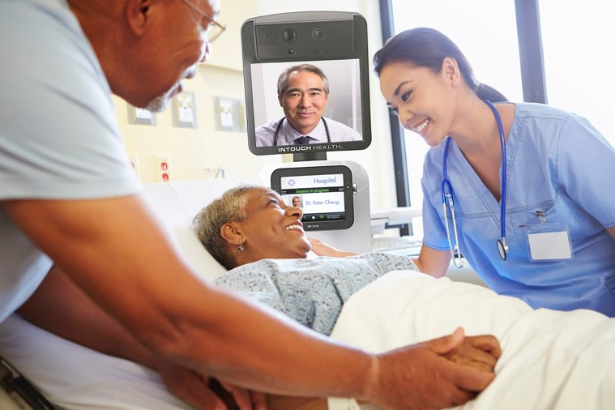
Source: https://www.theverge.com/2019/3/11/18256929/telepresence-robot-hospitals-patient-information-medical-news-ethics-kaiser
Much more than meets the eye, since its role in creating the aforementioned new ecological environment of the human experience is one of the key ones.

The need of reset
The sense of novelty is truly important here. The problem is that users have had time to feel not only the benefits of high-tech development but also its negative impact on their lives: alienation from traditional social interaction, cyber fraud and vague anxiety about the soullessness of the information environment have become an additional stress factor in our already challenging modern lives. People began to wonder about things they used to take for granted as evidence of the good of high-tech progress: do these technologies serve humans, or have humans become an appendage of technology? And what is the mission of the companies that set the tone of the high-tech market—Google, Apple, Facebook, Twitter and others? To make their users happier, or to utilize them as a resource for fabulous profits, without caring about the long-term social consequences of their business strategies?
Not surprisingly, some of the "inhabitants of the Internet" have decided for the exodus of social networks and encourage others to follow suit. In such circumstances, the perception of technology needs a "reset", but this can hardly be achieved only through the introduction of more functional services because the first reaction of many users to almost any announced changes is a spontaneous feeling of a trick. Obviously, this situation is unacceptable, and the new generation of technology needs a different—human-centered—image, based on reliable evidence of the real benefits brought to the experience of human existence.

Healthcare
In this perspective, perhaps the most relevant area is healthcare. And no wonder—after all, nothing is more important than our health and that of our loved ones.
The potential for the application of high-tech developments here looks almost limitless. Indeed, they can open the door to a new era in which medical care will be of unprecedented quality and, at the same time, commonly accessible, both financially and procedurally. Again, the new communication generation has a key role to play in this.

Medical system driven by 5G: massive therapeutic effect and unloading of the system
- 5G capabilities will enable telemedicine, remote surgery, uninterrupted patient monitoring, the dispatching of medical media files, proactive diagnostics, and much more.

Source: https://www.acc.org/latest-in-cardiology/articles/2018/10/14/12/42/harold-on-history-the-evolution-of-personalized-medicine
The COVID-19 pandemic exposed the vulnerability of today's health care system, but at the same time opened up promising opportunities for its development through digitalization. The main problem was unscalability, in other words, the direct dependence of hospitals on physical assets and human resources: the spike in the number of patients led to a critical overload, reaching the point of collapse. The consequences of this lack of readiness were often tragic: shortages of staff, equipment and available space led to deaths that might be avoided in other cases.
Of course, complete eradication of this problem can hardly be guaranteed; however, the application to this industry of advanced IT developments based on the collection of patient data, its intelligent analysis in real-time and proactive response to the epidemiological situation can dramatically reduce the likelihood of its recurrence.

P4 medicine
One of the key paradigms within this approach has been around and evolved since the beginning of the 21st century. It is known as P4 medicine (sometimes also called "personalized medicine"). It can be seen as the topological intersection of three phenomena of the information society: 1) systems medicine (based on systems biology), 2) consumer and social interaction-oriented healthcare, and 3) the digital revolution.
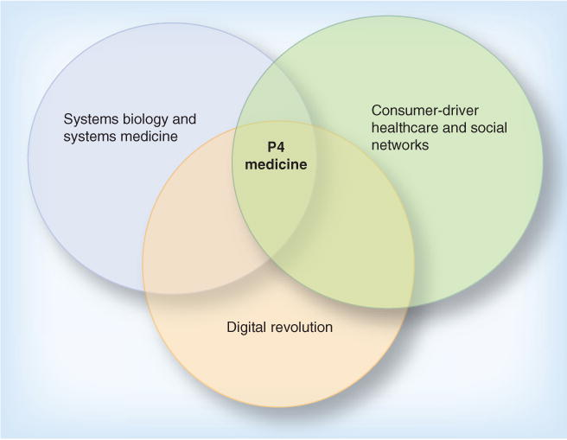
Three converging megatrends driving the transformation of healthcare;
P4 healthcare is emerging at the intersection of these megatrends:
Predictive, preventive, personalized and participatory.
Source: https://www.ncbi.nlm.nih.gov/pmc/articles/PMC4204402/
The internal structure of P4 medicine consists of the following components: 1) predictive: allows early detection of diseases, 2) preventive: is designed to take preventive measures to avoid the development of disease, 3) personalized: provides the opportunity to tailor treatment based on the analysis of the patient's DNA and 4) participatory: involves patients in the process of controlling their health.
All of these components require intensive data collection, processing and analysis. The need to move to 5G for this is a dramatic increase in network capacity, which will be required for the mass provision of remote services and accompanying distributed computing (the latter factor we will consider in more detail below). The new standard will enable the use of a huge number of medical devices (sensors, transducers, diagnostic appliances, etc.), the handling of large volumes of transmitted information, such as patient data, media files, etc., and the parallel use of video communications without any restrictions. It will also be possible to use a digital copy of the patient's body, a so-called "digital twin", which allows to visualize organs, monitor their condition and perform predictive modeling of therapeutic strategies. This approach already exists and promises to bring with it enormous benefits, given recent advances in Machine Learning / AI. But, as in many other cases, its development is constrained by the lack of communication infrastructure.
So, the planned preventive orientation of the medical system will make it much more flexible than it is now: digitalization will radically increase its resilience to overload, and proactive actions with regard to the health of patients will reduce their morbidity. This will not only achieve a new level of therapeutic effect, but also solve the strategic problem of eliminating the direct dependence of the system's performance on the physical infrastructure of medical institutions. There is no doubt that these changes will bring tremendous benefits to people on both an individual and societal level.

Telemedicine
The mass introduction of high-tech devices that monitor the patient's condition, applications that analyze the data obtained and visualize the results, combined with the new capabilities of mobile networks, will allow the development of telemedicine. This trend has already been stimulated by the COVID-19 pandemic and the resulting forced limitation of physical contact. Medical institutions have begun to offer the possibility of remote communication between patients and doctors. However, this service loses out to live communication with a specialist because, firstly, it creates a spatial barrier to communication and, secondly, it does not allow for an examination of the patient accompanying the visit. The new digital infrastructure being deployed as 5G rolls out will eliminate these shortcomings by getting the data you need in real-time and using VR/AR applications that provide a telepresence effect. But the improvements don't stop there.

Internet of Bodies
Technologies for transmitting and processing biometric data have given birth to a new term—the Internet of the Body (IoB). This area of IT, used in the medical and fitness industry, has been on the radar for some time. Many of those who take care of their health use various fitness equipment and wearable gadgets, such as fitness trackers/bracelets, smartwatches, etc. These devices measure the distance covered by their wearer, the number of calories spent during the exercise, current physical parameters of the body, heart rate, blood pressure, etc. Some manufacturers even claim that their products are capable of monitoring a persons' emotional state, improving their sleep, etc. Along with these, there are even more impressive developments—"ingestible" or "embedded" devices. And this area of medical service expansion is the most sensitive to the conditions of the information infrastructure into which they are integrated.
So, the first type of development is the so-called digital pill, a miniature device swallowed by the patient. It can perform such functions as visualizing the condition of internal organs, monitoring medication intake and its effect on the body, analyzing metabolism, hormonal balance, the presence of infections and disease progression, etc. After the patient consumes the "digital pill", it begins transmitting data to a special sensor similar to an ordinary patch glued to the torso. From there, the data are sent to a mobile device with an app installed that allows you to see the information being transmitted.
The second type is implantable microchips, which allow patients to store their medical information inside their own bodies and transmit data about the condition of their bodies without the need to use any gadgets. The most advanced type of these devices—neurochips—go even further, allowing to correct neuronally determined dysfunctions of the body by affecting the CNS (perhaps the most famous example of the development of such devices is Neuralink). In fact, this approach implements the idea of brain-computer interface, which seemed pure fantasy not so long ago, now making some futurologists, techno-philosophers, IT evangelists and others talk about the beginning of the epoch of human cyborgization.
There is no doubt that the development of 5G infrastructure will take the effect of such devices to new heights, since their functionality, reliability and practical utility depend on the capabilities of their informational environment—in terms of network bandwidth, computing power and the way data is exchanged. So far (2022) the level of development of both constrains the unlocking of the potential of the above developments. It is natural to expect these limitations to diminish as 5G is implemented.

Remote surgery
There is every reason to believe that one of the most significant areas of the renewed healthcare system will be remote surgery (also known as telesurgery). It brings with it four major advantages: 1) the obvious, following from its name—it allows surgery without the physical presence of a surgeon; and (less obvious)—2) it compensates for the shortage of surgeons, 3) increases the surgical precision of the operations performed, and finally, 4) provides control of the operation from different, distant locations.
It should be noted that since the first remote surgery (2001), this field has been enriched by several innovations, in particular the Virtual Interactive Presence technology (VIP, 2014), which allows remote surgeons to interact with a common three-dimensional (3D) display using high-definition binoculars. However, the developed enhancements, as in many other cases, are bogged down by the problem of data transfer. Specifically, we are talking about the time delay in the transmission of audio-visual feedback between two remote locations. Not only does this delay lead to delayed operation time, but it also causes significant surgical sloppiness, negating the unprecedented precision of manipulation inherent in modern medical robots. In order to take advantage of this option, data packets need to be exchanged at a frequency 4G cannot provide. The real operational difference between 4G and 5G in data exchange can be clearly seen in the previously mentioned video "The low latency difference", which implies that only the new standard will allow remote manipulations of high complexity, such as those shown in the demonstration video "da Vinci Robot Stitches a Grape Back Together".

Tactile Internet
Until recently, telesurgery suffered from the conceptual flaw that the operator relied mainly on visual feedback. But in the future, this gap may be filled with technology that allows tactile information to be transmitted. It's called Tactile Internet (TI), and it senses the consistency of tissue and the tension of sutures, preventing unintentional damage. As a result, the surgeon's confidence during manipulation and control of the operation is increased. The key to achieving the desired effect is to reduce data latency to below the human perception of proprioceptive/tactile latency in a real physical environment. The 4G standard does not allow to achieve this with sufficient reliability, so all hopes are pinned on the next generations of mobile communications. 5G comes close to meeting this challenge, reducing latency by an order of magnitude (to a realistic 10-30 Ms vs. 100-500 Ms).

Innovations and Future


Confidence in positive change
It is not known for certain whether the practical implementation of TI will be possible in a 5G environment or will have to wait for the next standard. The fact is that 6G reduces latency to less than 1 Ms, while the practical 5G figure—up to 10 Ms—still does not guarantee all the necessary conditions for this. But there is already at least one approach that potentially solves this problem. In October 2021, Ericsson unveiled its innovative Time-Critical Communication solution designed "to eliminate latency and interruptions in 5G networks." As stated in the press release, "Ericsson's solution provides consistently low e2e latency (50 Ms to 1 Ms) with a guaranteed rate (99.9-99.999%)—all to create scalable use cases for which latency is critical." It's not yet clear how effective these scenarios are against TI; Ericsson is hoping to deploy this solution on a large scale during 2022, so it will likely be several months after this article is published before the situation becomes clearer. But even if we have to wait for the next 5G standard to come, it already plays an extremely important role in the development of human-centered technology. Above all, it is important to be sure that the circumstances affecting their progress are taken into account, calculated and controlled, and the timely transition between the relevant standards together with the deployment of the accompanying network infrastructure is evidence of such control. In this sense, it is again important that 5G is not an episode among other technological improvements, but a link in a chain of successive progressive changes. And today, we can say that this process is proceeding in a fairly dynamic way, despite the severe challenges the COVID pandemic has posed to the global community.

Not stopping there
However, by talking about TI we, willy-nilly, touch on a broader issue than solving current problems in this or that area of human activity. We are referring to the future, which even from today, where we are already surrounded by very advanced technologies, still looks fantastic. It's not just that this technology requires a new level of mobile communication and network infrastructure. In order to make it part of reality, we will have to solve several extremely complex related problems (such as the development of ultrasensitive manipulators, the realization of the interaction of human senses with digital data, and others), which have not yet been part of the high-tech business agenda. Nevertheless, despite the difficulty of achieving these kinds of goals, there is hardly any doubt that the future we are talking about will come—regardless of our ability to foresee its shape. Clearly, an important part of the social consensus is the desire not to rest on our laurels. The rejection of technological progress is unthinkable, except as the result of fatal stagnation in the development of innovation, which in itself is highly questionable.
On the basis of all this, it is hard to find excuses for not taking care beforehand to have an image of this future that is socially acceptable and motivating to make efforts in the chosen direction.

Entire spectrum of human sensations

The merging of two worlds
So, TI lifts the veil over the world of the next generation of high-tech, opening a new perspective on the relationship between the two realities—physical and virtual. Obviously, these new possibilities will be in demand not only in medicine but also everywhere where the subject of interaction with the environment needs to overcome the barrier between the visible and perceived worlds. But our senses are not limited to the tactile, and this type of sensory exchange is part of a broader concept known as the Internet of Senses. This approach is intended to bring the full range of human sensations received through the senses, including sound, smell and taste, into the virtual world.
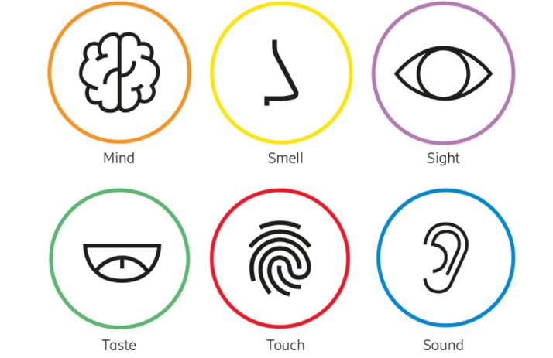
Internet of Senses.
Source: https://www.ericsson.com/en/6g/internet-of-senses
Here it could be noted that we are not talking about "real" sensations, but about their digital imitation. However, their perception can be identical to the natural one if the same feedback loops between the neuronal and perceptual systems of the human body are involved. In this sense, they become no less real than those received when interacting with the physical world, which will allow speaking about the actual disappearance of the border between virtual and physical realities, just like it was shown in the fantasy world of Avatar. On the technical side, the goal is, firstly, to achieve the desired intensity of data exchange between the body and the "expanding" devices. The saturation of this flow should be comparable to the volume of incoming/outgoing signals received in the process of natural interaction of the subject with his/her environment. Secondly, it requires conversion of the incoming data into an appropriately mapped neuronal response, which in turn sends a signal to the device or a virtual copy of the body, leading to their expected functioning/behavior.

Challenging the Evolution
Not surprisingly, the full realization of technologies of this kind is still hard to imagine. This task looks not only extremely ambitious but also borderline in terms of human ability to understand the mechanics of life, which took evolution hundreds of millions of years of trial and error to develop. Direct body-computer interaction implies intrusion into the holy of holies of our bodies—the extremely complex, delicate and largely unexplored world of the human CNS. But humans have one advantage over nature: while it is blind, we are not. We have the ability not only to convert the ingenuity of the human mind into high-tech tools but also to accumulate experience in their application. What seemed impossible twenty years ago is now perceived as difficult: there are already prototypes of neuro interfaces that allow test subjects (usually, people with motor disorders) to interact with the world around them literally by the power of thought. This, of course, is just the beginning, and no one knows exactly how long it will be before reliable, fully functional devices appear and spread. But such obstacles have never stopped humans from pursuing tasks that they are convinced are worthwhile. Especially when the goal is stipulated by the desire to get rid of the limitations of the human condition (the idea of Avatar certainly expresses a dream of just such a kind).

The embodied internet
Needless to say, in a world of free enterprise, any human desire that can be recognized and satisfied in the foreseeable future becomes a matter of commercial interest. This perspective, in turn, is constituted by the current technical possibilities, the availability of resources and the trends in the development of the most advanced technologies. The horizons of the desired here always extend beyond what is possible here and now (because in order to change something, we must first imagine this "something"). And it should be noted that those who form these horizons—and we are talking about the giants of the IT industry—have no problem with imagination. Not to mention the resources and innovation potential.

Meta
On October 28, 2021, an event occurred that, in retrospect, could acquire the status of the beginning of a new era in the history of the Internet and everything associated with it. Facebook CEO Mark Zuckerberg announced a change in the company's name—now Meta—and its technical mission. From now on it consists of transforming the mobile Internet into what he called "the embodied Internet". Its purpose is to put the user in a virtual reality center, where
…we'll be able to feel present like we're right there with people no matter how far apart we actually are… when I send my parents a video of my kids they're gonna feel like they're right in the moment with us not peering through a little window when you play a game with your friends you'll feel like you're right there together in a different world not just on your computer by yourself and when you're in a meeting in the metaverse it'll feel like you're right in the room together making eye contact having a shared sense of space and not just looking at a grid of faces on a screen that's what we mean by an Embodied Internet instead of looking at a screen you're going to be in these experiences…
Zuckerberg does not make precise predictions about how long it will take to implement these plans, cautiously reporting that "this path... will last decades.” But that caveat doesn't seem like a deterrent, since the actual goal is not to achieve some final state of the "embodied internet," but rather a series of progressive improvements designed to "enhance the user experience. And Zuckerberg has a roadmap for this, outlining the main stages of these improvements and a strategy for their implementation.
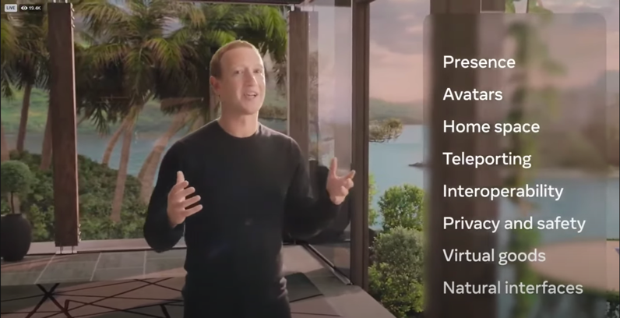
So, the fundamental property of the Metaverse should be the effect of presence, when a person's perception should not be projected onto the virtual world, but come from his subjectively perceived center. The user himself appears in it as an avatar (of course), to which the language of the real physical body and facial expressions corresponding to his current emotional state are transmitted and authentically reflected in their behavior. Similarly natural should be the sound and manipulation of virtual objects. It is possible to be present in different kinds of realities, for which appropriate devices are designed: Oculus—for VR, "smart" glasses Ray-Ban Stories—for AR (also being developed another, an advanced version of glasses).
While none of the above is individually conceptually revolutionary, the intent behind the Metaverse deserves that status. The Metaverse is even difficult to characterize by any existing term since it combines the attributes of different platforms without being exactly one of them. And unlike all the others, it regards the user experience in all its manifestations as its main goal, stating a commitment to its continuous improvement. To this end, it plans massive investments not only in platform software and hardware but also in research and development activities, in particular those related to the development of neural interfaces.
Perhaps the "embodied Internet" could be called an Alternative Reality Space, allowing you to meet people who exist in the physical world and engage in activities similar in content to the real world (work, study, leisure, sports, entertainment, commercial activities, etc.), but with the specificity of virtual reality, as well as doing things that are only possible in the Metaverse. And of course, this world can be filled with content as you see fit.
As it follows from the presentation, the actual work on the implementation of this idea began at least seven years ago. However, something similar had emerged much earlier—back in (now) 2003, when Second Life appeared. But while it has just over a million active users, for the Metaverse the count must be in the billions. Of course, one of the main reasons for this is that Facebook already has those users, but not only that (in fact, it's not certain that it will be Zuckerberg's brainchild). We can assume that the embodied internet will indeed be the next version of the global network, for reasons rooted in the deeper layers of the human mind. The metaverse promises the user an idealized version of reality that, unlike the ordinary world, is under his or her individual control. In this reality one is not bound by the constraints of space and time, no one and nothing threatens that person, and he/she can experience sensations that are difficult or impossible to obtain outside it. And the more realistic this constructed reality becomes, the less utopian it will seem to everyone.
How far can this go? We believe that as far as the means of technical implementation will allow, up to the complete erasure of the perception boundary between the "real" and the virtual world. There is no doubt that the embodied Internet will evolve in this direction—this follows not only from Zuckerberg's stated intentions but also from their technical implementation. In particular, along with the stylized avatars common to video games, Meta plans to provide users with hyper-realistic avatars indistinguishable from their real appearance, with these users in an equally realistic-looking environment.
The developers of the Metaverse have already made impressive progress toward their goal. And although according to Zuckerberg's statement it will take about a dozen major technological breakthroughs for the full implementation of the announced plan, the embodied Internet is close to launching in the state of the Minimum viable product.

Other Metaverses
Obviously, different network access conditions of the user can make adjustments to the formation of the primary experience of some of them: traveling through 3D worlds and interacting with objects within them imposes higher requirements for connection speed, bandwidth and especially—latency. While there remain regions with undeveloped 5G network infrastructure, not all of these requirements can be fully met for mobile Internet users.
But it seems that these concerns are not significant in light of the expected benefits, and other versions of metaverses have already appeared, some of which began to take shape even before Zuckerberg's announcement. Thus, in fact (and importantly), the word "Metaverse" has come to refer not to any particular product, but to a class of products.
A landmark event was the announcement of Microsoft's intention to create a metaverse. For starters, it is going to implement it in its MS Teams as early as 2022 based on its own Mesh mixed reality platform; the AI is supposed to be used to listen to the user's voice and correspondingly animate his avatar with the corresponding lip movements. Switching to 3D meeting mode will also result in additional hand movements. It may not look as audacious as the options in Zuckerberg's presentation, but you have to start somewhere. And, in confirmation of the seriousness of their intentions, barely 2022 has begun, Microsoft announced the acquisition of Activision Blizzard for $ 68.7 billion. The statement indicates that, among other things, the platform will be used to create Metaverse building blocks.
Also, Roblox, Fortnite, Decentraland, The Sandbox, Unity are already developing or planning to start developing metaverses in the near future… and the trend is only gaining momentum. The Metaverse is penetrating the minds of business people and it seems that the success of this expansion is predetermined.
Interestingly, among the companies entering this stream, we can find several telecommunications companies that have begun to create components of their own meta-universes. Among the pioneers here are such giants as China Mobile, Verizon and SK Telecom, which are also leaders in their regions in the implementation of 5G. Undoubtedly, as Telco representatives, they are more aware than anyone else of the benefits that can be derived from the application of the new mobile communications standard in this new world of metaverses. So it is natural to assume that their business strategies in this regard are based on the ability to convert this awareness into real profits and increased market share.

Meta-Summary
So, by 2022, the term "Metaverse" had become part of the high-tech world, immediately making the definition for an entire class of products. The significance of this event remains to be fully assessed, but it is already clear that it marks a fundamental shift in the perception not only of information technology but also of the role of technology in people's lives. The metaverse turned out not to be included in the space of technology, but on the contrary, it included it in itself, thus forming a paradigm based on the primacy of human experience. It is henceforth human (aka user) experience that will be the main measure of a product's value. From this point of view, the term "embodied Internet" seems to us absolutely appropriate. Meta-voice was not only heard but also picked up, and in all likelihood, in the not so distant future it will be impossible to imagine many human activities—work, study, entertainment, etc.—without association with the new informational environment, where, as the users believe, everything is possible and everything depends on their desire.
It seems to us that the beginning of the "embodied Internet" at this particular period of time is natural. In the sense that, as we noted earlier, the implementation of any idea is only possible under a certain combination of circumstances. The metaverse is a space of connected entities that would not be viable without a gravitational force capable of providing that connection. The communication industry is the conduit for this force, and its condition determines the limits of technology's embodiment in today's super-connected world.
Thus, we believe it is a mistake to think of the new generation of mobile communications only in utilitarian terms. In our opinion, its adequate evaluation requires its comprehension as a connecting link in the interaction of solutions satisfying the demand for building a society that declares more strongly than ever its interest in fully satisfying the tangible needs of its members.

The epoch of smart machinery
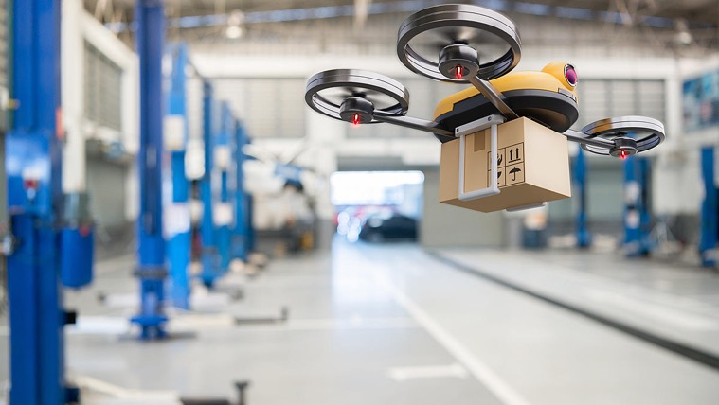
Source: https://disruptivetechasia.com/big_news/the-role-of-drones-in-building-safer-asian-cities-in-a-post-covid-world

Benefits, Complexification and Control
It's impossible to imagine modern life without machines. They bring us fantastic benefits, and that is why they are everywhere. In this context, it is not so surprising that the number of vehicles, machine-tools, various instruments and intelligent devices all over the world exceeds the number of people many times over, and as the Internet evolves, this numerical superiority increases at an accelerated pace.
Meanwhile, over time, these devices are becoming not only more numerous, but also more complex, which makes controlling them a separate challenge. The problem is exacerbated by the fact that some of them are designed to be highly autonomous and often mobile. The usual requirements are for them to be safe for people and not to interfere with other devices, and sometimes they need to communicate as well. The most advanced solution is to integrate them into a common information-computational environment and have them communicate effectively and in a coordinated way via a mobile network. Self-driving cars and drones are the most obvious examples, but they are not the only ones, and stationary production equipment that interacts with external objects can also be mentioned.
This range of tasks forms a vast industry niche, the largest segments of which are the production and control of vehicles. And this niche is the most important area of application of the new generation of communications represented by 5G.

5G relevance for manufacturing
Modern production processes are complex and impose critical demands on the physical state of the mechanisms, their operational accuracy and their ability to communicate. The consequence of this is the need for a large number of sensors (which can be combined into multi-sensor platforms, MSP) and a corresponding communication system for data transfer, which in many cases can only be wireless. In a 4G environment, the immediate problems here are limited network capacity and latency, and the indirect problems are the lack of efficiency due to the need to use Wi-Fi for local routing, which has its own limitations. Which in turn inhibits the use of other approaches (in particular Edge; we will touch on this issue a little later). 5G with its advanced capabilities allows solving these difficulties. Here, it not only provides improved network interaction but again acts as a nexus for several advanced technologies. In fact, it makes it possible to implement the concept of Industry 4.0, sometimes also called "smart manufacturing". In particular, it significantly increases its flexibility by enhancing its customization capabilities and extensively introduces autonomous operations and monitoring to improve productivity and product quality.
Essentially, 5G brings to the manufacturing domain the same benefits we described earlier for healthcare or the "embodied Internet" (which, in turn, integrates the educational, entertainment, workplace and other ecosystems). As different as manufacturing is, behind the changes that come with 5G in all cases are radically reduced connection latency, increased bandwidth (although connection speeds should not be discounted either) and access to expanded computational resources. And if you metaphorically imagine 4G as an urban bicycle path, then 5G is a highway that not only has orders of magnitude more traffic but also connects cities, not blocks.
Let's take a look at how exactly the characteristics of 5G may affect the structure of production.

Local cloud
We mean an approach based on the Edge concept. The general purpose of the latter is to move part of the computing from the end cloud closer to the periphery. This significantly reduces latency time, which is especially important for the manufacturing industry. As such, Edge is not rigidly tied to 5G, yet it is the new communications standard that makes its use most in demand. On the one hand, calling a local cloud (we'll consider this term interchangeable with Edge) rather than to a remote one reduces the overall latency value for both 4G and 5G, but on the other hand, the difference between these latencies, being almost imperceptible for human perception is technically substantial enough to significantly improve the effectiveness of this solution for the second case. For discrete production processes monitoring, the interphase interval of data processing is critical. If latency exceeds it, the control gets lost for the given iteration. Naturally, if this happens, then this approach turns questionable.
So, 5G maximizes the benefits of Edge proximity and allows to take the optimization of production processes even further by moving some of the data processing logic to the local cloud. In particular, for AGVs' (automated guided vehicles) software, which promises to reduce their cost, simplify their maintenance and unify their orchestration, significantly improving production transportation. Practical results include coordination of AGVs' routes, sharing use of navigation maps, etc.

Product quality control: MEC and Digital Twin (DT)
Quality is the cornerstone of the use-value of any product, and therefore of production. Not surprisingly, its control is of paramount importance. The main problems here are the complexity of standards' development, the laboriousness of the process (and therefore its cost) and the detection of hidden defects. The Multi-Access Edge (MEC) with hosted software that handles ML data is a key solution to these problems. It enables the DT approach we mentioned earlier (this time applied to production facilities), which provides near-real-time monitoring and control of production processes. This solution introduces complex digital models of physical systems into the production environment, allowing not only quality control but also timely detection of factory anomalies, analysis of current equipment performance, development of alternative scenarios for its usage and optimization through dynamic tuning. Among the data collection methods, wireless acoustic part monitoring and machine vision are the main ones. It should be noted that experts are very optimistic about the prospects for this approach, predicting that it will become widespread in the next few years.

AR/VR
Among other things, the use of DT makes it possible to enrich the production process with AR/VR capabilities. This technology is in great demand in Industry 4.0, as it opens up new horizons in quality control, communication in the workplace and the practical usage of professional competencies, as well as optimizing the training of specialists. Also, it increases the production environment safety by providing the operator with real-time, up-to-date data about the surrounding environment. It should be noted that it affects not only the technical aspects of production. Additionally, it increases workers satisfaction, which is extremely important in the context of the human-centered image problem of the new high-tech generation we discussed earlier.
- See the video: What If All Your Field Workers Were Your Best Performers? — https://www.youtube.com/watch?v=rtwYSjviYck

Safe environment
This safety issue is worthy of special attention because, after all, it concerns humans. Workplace accidents invariably attract public attention and, in addition to purely human misfortune, result in reputational damage for business. The above-mentioned methods for optimizing production processes contribute enormously to a safer working environment and, once again, are based on comprehensive information infrastructure, ultra-fast data exchange and smart analysis.
The most important use of these advanced capabilities is the physical interaction between humans and machines. The new information environment makes it possible to optimize this process considerably. First, physical interaction can be minimized through the use of DT and VR/AR, and second, through the enhanced ability of AGVs to detect other objects in their path, including moving things, and adjust their own movement accordingly. And since all mobile vehicles share the Edge's proximal computional resources, where AI can be connected to, it becomes possible to simulate various incident avoidance scenarios with the subsequent application of created and constantly updated models by all devices. And finally, (thirdly) a related approach can be applied to production robots to recognize the intrusion of extraneous objects and humans into their operating space, which not only improves safety but also opens up the prospect of more subtle interaction for human-robot collaboration (HRC).

Intelligent Transportation
The problem of transportation safety is inextricably tied with the problem of manufacturing efficiency, and in this connection, we can find a favorable corollary: Generally, production designers can consider either safety of the vehicle, the other means surrounding it and humans essentially as the one and the same problem. From this perspective, is useful to see the 5G informational environment as a conceptual framework having pre-installed means to address it.
For urban environments, high-tech solutions to similar problems began to be developed as mobile networks evolved and their bandwidth increased. Before 5G, an approach known as DSRC (Dedicated Short Range Communications) was common. This technology allows direct communication between vehicles using Wi-Fi. It allows controlling the distance between them and to avoid collisions effectively. While this system is well established, with the introduction of 5G another approach known as C-V2X (Cellular Vehicle To Everything) is becoming more promising. Unlike its predecessor, it uses the mobile network, making the vehicle control system part of the global 5G network, with all its advantages, including ultra-speed Edge computing and the use of AI. So, while the DSRC is a highly specialized approach aimed at preventing vehicle-to-vehicle incidents, the C-V2X takes street traffic control to a new level. Much more detailed analysis of the vehicle environment becomes possible, in fact, unconstrained by the topology of the surrounding space. The use of AI in the local cloud will enable instant creation and on-the-fly optimization of advanced interaction scenarios for all traffic subjects—not only cars but also pedestrians and even animals. The models created will include intelligent analysis of on-board and external sensor data. All this will be performed in near real-time and will be available as a shared resource. Thanks to this, vehicles will gain much more than human "perception" and will be able to react much faster and more accurately. Thus, the integration of transport units into a single network makes the state of each of them an integral part of the state of the entire network, which means that their individual state cannot be ignored, unaccounted for, or lost.
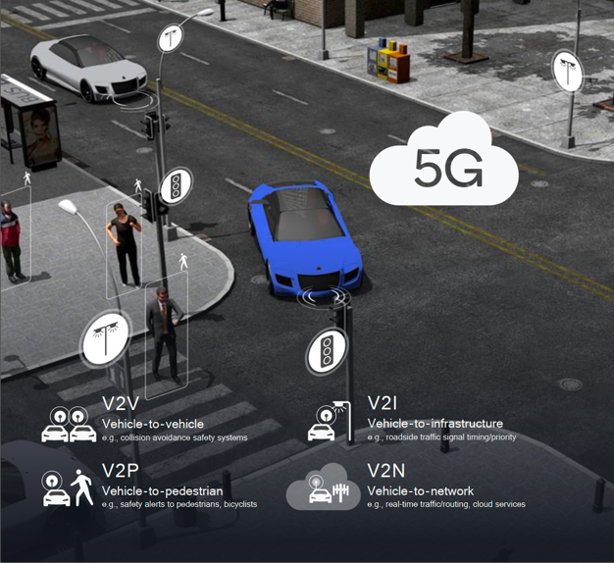
Intelligent traffic, based on C-V2X. Source: Qualcomm.
Obviously, these advantages are in high demand for self-driving cars: in the absence of human control, the requirements on the intelligence of their control system are dramatically increasing since the latter faces the need to solve non-trivial tasks for a computer. 5G will allow getting as close as possible to this level of intelligence: while all cars exchange very small packets of information, "understanding" the overall state of their environment requires processing much larger amounts of data, and all components are important here—the speed of their sending, the fastest processing and the minimum delay in receiving the network response.
- See the video: 5G and the Future of Connected Cars — https://www.youtube.com/watch?v=x6DfzkeQpQ0

Inside Smart city
The impact that the environment makes on human existence cannot be overestimated. As biological beings, we are in direct, though not always obvious dependence on it. For modern cities, this problem is especially relevant, because they have almost nothing in common with the natural (i.e.—primordial) environment of our species.
One response to this challenge of mismatch is the concept of the Smart City. Its origins can be found in the early 1970s. It has its springs in the early 1970s, when computers began—discreet at the time—to infiltrate human life.
In a nutshell, the essence of the idea is the digitalization of urban space and maximizing the benefits for all urban residents (an important aspect of which is the concept of Open Data). Not surprisingly, the idea gained popularity with the development and democratization of IT, and in the early 90s, the first Smart Cities appeared, utilizing appropriate solutions in such areas of urban life as transportation, the safety of humans and communications, efficiency of municipal services and natural resources usage, urban management, budgeting, etc. But, as in all the cases we have discussed earlier, the full implementation of this concept places increased demands on the capabilities of the information environment. This applies, first of all, to various mobile/autonomous devices, both ground and air, as well as to those controlled from a distance (such as snowplows, garbage trucks, repair robots, etc.), i.e. all those whose safety largely depends on the rapid exchange of data with the surrounding informational environment.
Until the introduction of 5G, these capabilities remain limited, and cannot cope with the surge of data sent by sensors installed everywhere in the urban landscape, in vehicles, urban infrastructure and dwellings, not to mention the ability to process all these streams promptly. Meanwhile, the key task for the cities of the future is not just to control the state of streets, communications, loading of parking spaces and garbage cans, environmental indicators, etc., but to gain an understanding of the state of the entire urban organism. And the most important hallmark of this condition, again, is the satisfaction of the inhabitants.
Another problem is the constant complexification of the structure of urban life, which can also include the prediction of human behavior in situations where it depends on the loading of municipal infrastructure and various services.

Talkative appliances
Many of the solutions we've reviewed, starting with the section on healthcare, belong to the Intelligent Connectivity paradigm. This overview is enough to get a good picture of the subject, but it makes sense to highlight clearly one of its components: the IoT (Internet of Things). This approach is now extremely popular and one of the fundamental ones for areas where intensive collection and exchange of sensory data between devices without human intervention is necessary. The human dwelling can be regarded as an elementary social node in the urban structure, accordingly, the tasks solved by this node are similar, but only on a smaller scale, to those of the entire structure. IoT is also referred to as home automation. It includes control of lighting, heating, energy consumption, air conditioning, media- and security systems, including video surveillance. Such systems need to be flexibly configurable, sufficiently intelligent and controlled remotely via a mobile app. And while many components of such systems don't require very fast communication, there are exceptions, particularly regarding residential security. Many AI applications have made impressive progress in facial recognition, but in the future, they are likely to use more advanced approaches. It will become possible to reliably identify people and predict their intentions without the use of pre-created data models (for which Deep Learning is currently used), or this need may be minimized. The result will be achieved by using next-level AI based on Biological Neural Networks, an approach that allows machines to not just compute, but actually think—essentially the same way our, human brains do, while being free of their natural (biological) limitations. Undoubtedly, such an approach will be in demand in many fields of human activity, but its implementation requires data exchange, the density of which is comparable with that inherent in human perception, and most likely even higher.

In summary
So, the advent of 5G promises important changes in areas of human activity related to, and sometimes directly dependent on, machine production. Broadly speaking, this refers to the whole interaction between humans and the devices they create, and more and more recently, devices with each other. In this new era of smart machinery, their functioning will be so complex that the term "behavior" will be more appropriate for it in many cases. But their purpose remains the same: to serve people, which means that this behavior must be useful, safe and controllable for us. The new generation of communication is a key means of achieving this objective. Its role is not only due to its original purpose, but also goes beyond it, becoming the cause of the synergy of multiple innovations. This is the case when the whole is greater than the sum of its parts, when—and if—these parts can seamlessly integrate into a common backbone network, as 5G infrastructure should be and is already becoming.
Finally, consider the last reason that makes the introduction of 5G inevitable. Moreover, it is what implies it to be immediate.

A geopolitical factor
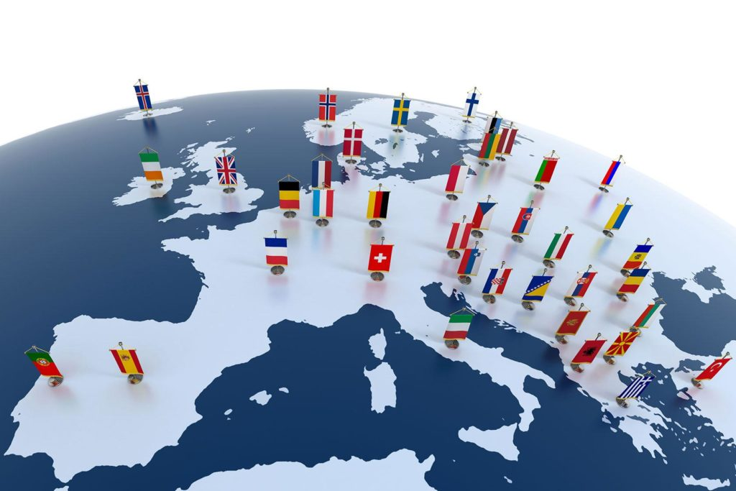
Source: https://symbiosiseurohorizons.wordpress.com/2021/04/11/covid-19-europes-changing-geopolitical-landscape

A threat to Sovereignty
Advanced technology has never been a politically neutral subject since it has meant a military or economic advantage for its owner over all others. Although it may seem that for the modern globalized world this problem has lost its acuteness, no one has cancelled the fact that the more the subject of international politics is dependent on imported technology, the more the realization of its interests is prone to be influenced of that technology exporter's interest.
A clear confirmation of this dependence can be found in the EU's policy regarding the development of advanced IT on the Old Continent. Europe's lagging behind other major geopolitical players (the US, the Asia-Pacific region and China are usually mentioned among them) has for some time been sufficiently worrying for the EU leadership to regard this state of affairs as a threat to its sovereignty. And this is not someone's private opinion at all—this, as well as the urgent need to change the situation, is directly stated in several EU policy documents, one of which is the State of the Union Address of September 16, 2020, where President Ursula von der Leyen has laid out:
But Europe must now lead the way on digital – or it will have to follow the way of others, who are setting these standards for us… This is about giving Europe more control over its future… We want to lead the way, the European way, to the Digital Age: based on our values, our strength, our global ambitions.
It should be stressed that we are talking about problems not with the use of high technology, but with its development. The global IT hegemony of the United States, Europe's closest partner and ally, had a contradictory effect for the latter: on the one hand, the arrival of overseas technology allowed European companies to do business successfully, but on the other hand, it did not give European users control over their own data. In a world where information is everything, this is bad in itself, but as it turned out, the problems were not only about software and big user services but also about the implementation of advanced scientific developments, the investment climate, the production of computer parts, etc. Thus, the EU found itself in a losing position compared to its trading partners, and the COVID-19 pandemic exacerbated this problem by revealing the need for a coordination system for the European Community member states, that is independent of external providers.

Navigating the Digital Decade
The EU's mechanism for addressing issues of such level includes the development of appropriate Strategies, Priorities, Policies and Policy Programs, and so far, one of the priorities for the period 2019-2024 has developed two strategic lines—Shaping Europe's digital future and Europe's Digital Decade: digital targets for 2030. But as matter of fact, the work in this direction has begun quite a long time ago, even before the pandemic. Particularly, in 2013 there a public-private partnership 5G-PPP had been established, having designed to promote European leadership in high technology. In 2016, the European Commission's 5G Action Plan was drawn up, containing a roadmap for member states to create 5G services and products, and in 2018 the so-called European 5G Observatory emerged to monitor progress in achieving EU goals in this area.
Thus, the European Commission did not start from scratch and finally, in March 2021, work began on the political program "Path to the Digital Decade, which is also called the Digital Compass. It contains four areas of activity: Skills, Infrastructures, Business and Government:
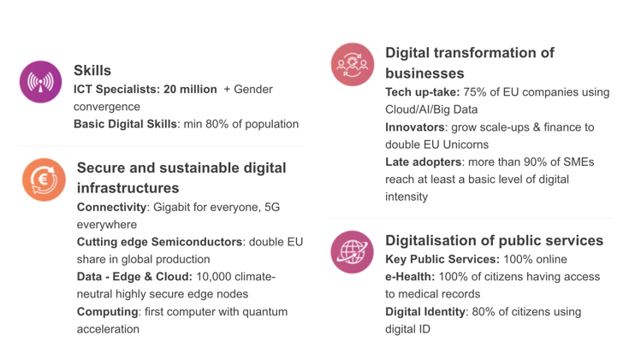
Digital Compass
A key component of this program is for the EC to join and coordinate efforts with member states to deploy 5G infrastructure across Europe as soon as possible. Participants in the program are invited to present national strategic roadmaps for the Digital Decade to the Commission to achieve the digital goals by 2030.
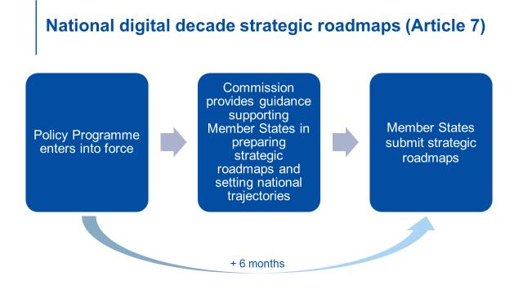
Стратегические дорожные карты Национального цифрового десятилетия.
The process will be monitored annually and also once a year the European Commission will provide the European Parliament and the Council with the "State of the Digital Decade" report. In addition, the 5G-PPP's report (European 5G Annual Journal) contains information on the implementation of projects launched as part of it. The most important strategic point of the program is the possibility of creating multinational projects by the Commission and one or more member states in order to facilitate the digital transformation of the Union and in particular to attract large-scale investments (by the time of the working paper of the program (March 2021) ten projects were foreseen with a subsequent increase in their number). The EU can act as one of the investors for this kind of undertaking for which there are several programs—Digital Europe, Connecting Europe Facility (CEF), Horizon Europe, Horizon 2020 and Invest EU—to evaluate and promote. The NextGenerationEU fund also invests 20% in digital technologies.

A supreme priority
The EU's efforts to digitalize the continent are extraordinary in both scope and funding. President von der Leyen called it in a Keynote speech at the "Masters of Digital 2022 event" "our Marshall Plan for a Digital Europe," a characterization that must be recognized as relevant to the level of European ambition. In fact, it is more than a question of "reconstruction" and "digitalization," but rather of a massive reorganization of the way modern society functions. In essence, digitalization is not a measure of improvement, but a means of changing the rules of the game, and not only on the European continent. Why? Because it should become the main tool for the implementation of the EU's mission, its Holy Grail—the creation of a Sustainable Society for the whole of Europe. Commitment to this paradigm is the ideological rationale for "our Marshall Plan.
The idea of sustainability, of course, is not an EU invention. Earlier we mentioned the widespread proliferation of an ecocentric worldview in public discourse, but it is more correct to consider it not as a separate phenomenon, but as part of a broader appearance, yes,—Sustainability. The meaning of this term is intuitively clear, but, as is well known, once adopted by politicians, any word can acquire a special meaning. And in this case, it is important that the EU invariably includes the so-called Digital Economy and Society Index (DESI) in the sustainable society metric, which summarizes the digital efficiency of Europe and tracks the progress of EU member states.
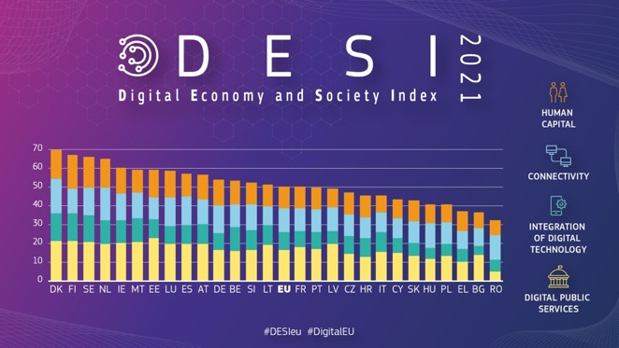
Digitalization here minimizes the effect of the internal contradiction inherent in the concept of a sustainable society. One of the conditions for the latter is a high level of well-being, but achieving it leads to increased resource consumption, which, in turn, reduces sustainability. This is the reason for the persistent calls on both sides of the ocean to curb and, if possible, reduce the level of consumption in society. But how can this be done in a growth-oriented economy (as we mentioned earlier)? Mass digitalization is designed to help solve this problem, firstly, by allowing people to achieve certain goals without physical interaction with the environment, secondly, by optimizing various processes that require the consumption of natural resources, and finally, thirdly, by bringing the economies of technologically advanced countries as close as possible to its "circular" type by developing ultra-modern ways of handling materials and waste management.
These plans, of course, do not seem extravagant; after all, the most important purpose of computing systems is to solve advanced problems of human activity, including the modeling of complex processes. However, the sense of the term "digitalization" has now gone beyond its original utilitarian meaning: just as 5G acts as a connecting link in the creation of new information infrastructure, the digitalization paradigm becomes a bridge between the society of today, where digitalization serves as a means of improvement, and the society of tomorrow, where it must not leave anything that is not optimized.
Here again, the pandemic has undoubtedly played a role, showing that our governing social systems require an additional—preventive—functional level. As it is put in one European Policy Center document,
It is in the EU's interest to use the COVID-19 crisis to start building the conditions for people and businesses to emerge from this crisis stronger, with the capacities to face the next one.
This means that digitalization must lead to a comprehensive, redundant—in the sense of sustainability—and scalable management information system that embodies all the goals of the Digital Decade. Thus, it is not just a question of developing the IT industry of a state or region, but of investing in the infrastructure of global sustainability.

Policy coherence for development and the deployment of 5G
It is also a contribution to the geopolitical weight of the EU, and—more significant than the usual increase in technological competitiveness. As stated in the European Commission Twitter:
Europe must lead the transition to a healthy planet and a new digital world.
This mission obviously follows the UN agenda Transforming our world: the 2030 Agenda for Sustainable Development, and in this sense, it extends beyond the Old Continent: Europe, as a member of the broad international community, is interested not only in meeting its formal obligations but also in maintaining its status as a key geopolitical player. Actually, unlike the U.S. or China, it needs to take care of the internal cohesion of its members, since the EU is not made up of states or provinces, but of sovereign states. European peoples undoubtedly have a profound cultural commonality, but this does not tantamount to equal development, and the EU has to make efforts to harmonize the actions of its members. To this end, the EU has a policy of Cohesion for Development, and it is currently being successfully applied to achieve the goals of the Digital Decade. In particular, large-scale deployment of trans-border 5G corridors along European transport routes (which is one of the multinational projects) is planned, and for this purpose, the EU is allocating massive investments from 2018.
***
So, the deployment of 5G in Europe is taking place as part of the continent's Digitalization Plan. It uses EU funds and attracts external investments, including injections into large-scale multinational projects. In its activities, the EU relies on expert assessments of specialists in all the areas involved and keeps monitoring the implementation of the plan.
But of course, all these activities have an effect on the implementation of 5G not only on the European continent. In the context of globalization, it inevitably affects a similar process in other regions and probably to a greater extent than usual, since it is not only a matter of implementing interests of national businesses but also those of the world's largest coalition of nations, with perhaps the strongest scientific potential, enormous financial resources and vast experience in solving the most serious problems. All this leaves us in no doubt that the new information infrastructure will be widely deployed all over the world before the X-HOUR, which is considered to be 2025, when, according to experts' general assessment, the current 4G capacities will be exhausted and this will put the telecommunication service providers who have not implemented the new communications standard in their activities in an unpleasant situation.

Conclusion
At the beginning of our paper, we talked about the difficulty of predicting disruptive technologies. That's still partly true for 5G: It's still hard to predict what services and applications will emerge as it rolls out, but there is no doubt that it will be deployed across the board over the next few years. We've tried to do our best to tell you about the features of this new communications standard that will allow you to see the whole picture, beyond the usual idea of "just faster mobile communications". Of course, that communication will be much faster, but that's not why 5G matters. Its true role is to be the nexus between a mass of innovative developments that could significantly change our world in an unprecedentedly short period of time. It seems that this world, the one where we will feel that technology is our friend and not just a tool, is already within our reach, we just have to do what our reason and common sense tell.
So, you can think of 5G as an important part of our future; you can see yourself as an active participant and beneficiary of its future; but you cannot think of the future possible without the coming of 5G.
And of course, we are always happy to help you find the shortest possible path to that future.
Stay connected!

Sources and further readings

European Commission —
documents, resources and reports

Documents and resources
5G for Europe’s Digital and Green Recovery — https://digital-strategy.ec.europa.eu/en/library/5g-europes-digital-and-green-recovery
Commission implementing decision (eu) 2016/687 of 28 April 2016 on the harmonisation of the 694-790 MHz frequency band for terrestrial systems capable of providing wireless broadband electronic communications services and for flexible national use in the Union — https://docdb.cept.org/download/153
Connecting Europe Facility — CEF Digital — https://digital-strategy.ec.europa.eu/en/activities/cef-digital
Connected and automated mobility — https://digital-strategy.ec.europa.eu/en/policies/connected-and-automated-mobility
EU and EEA Member States sign up for cross border experiments on cooperative, connected and automated mobility — https://digital-strategy.ec.europa.eu/en/news/eu-and-eea-member-states-sign-cross-border-experiments-cooperative-connected-and-automated-mobility
Horizon Europe — https://ec.europa.eu/info/research-and-innovation/funding/funding-opportunities/funding-programmes-and-open-calls/horizon-europe_en
Investing to shape our future — https://ec.europa.eu/info/sites/default/files/research_and_innovation/strategy_on_research_and_innovation/presentations/horizon_europe/ec_rtd_he-investing-to-shape-our-future.pdf
Making strides towards an open and dynamic 5G ecosystem — https://cordis.europa.eu/article/id/435466-making-strides-towards-an-open-and-dynamic-5g-ecosystem
NextGenerationEU — https://europa.eu/next-generation-eu/index_en
Research & innovation – European Partnership for smart networks and services (Horizon Europe programme) — https://ec.europa.eu/info/law/better-regulation/have-your-say/initiatives/11899-Research-&-innovation-European-Partnership-for-smart-networks-and-services-Horizon-Europe-programme-_en
Towards a green, competitive and resilient EU economy: How can digitalisation help? — https://www.epc.eu/content/PDF/2020/Towards_a_green_competitive_and_resilient_EU_economy.pdf

Policies and Strategies

5G
https://digital-strategy.ec.europa.eu/en/policies/5g
Communication – 5G for Europe: An Action Plan and accompanying Staff Working Document — https://digital-strategy.ec.europa.eu/en/library/communication-5g-europe-action-plan-and-accompanying-staff-working-document

Europe’s Digital Decade
https://digital-strategy.ec.europa.eu/en/policies/europes-digital-decade
Europe’s 5G strategy in the Digital Decade — https://digital-strategy.ec.europa.eu/en/policies/5g-digital-decade
Europe’s Digital Decade: digital targets for 2030 — https://ec.europa.eu/info/strategy/priorities-2019-2024/europe-fit-digital-age/europes-digital-decade-digital-targets-2030_en

Programme “Path to the Digital Decade”
COMMISSION STAFF WORKING DOCUMENT Accompanying the document Proposal for a Decision of the European Parliament and of the Council establishing the 2030 Policy Programme “Path to the Digital Decade” — https://eur-lex.europa.eu/legal-content/EN/TXT/?uri=CELEX:52021SC0247
State of the Union: Commission proposes a Path to the Digital Decade to deliver the EU's digital transformation by 2030 — https://cyprus.representation.ec.europa.eu/news/state-union-commission-proposes-path-digital-decade-deliver-eus-digital-transformation-2030-2021-09-15_en
Factsheet (A Path to the Digital Decade: common governance and coordinated investment for the EU’s digital transformation by 2030) — https://ec.europa.eu/newsroom/dae/redirection/document/79267
The Publication in the Official Journal of the European Union — https://op.europa.eu/en/publication-detail/-/publication/91f485b4-16d1-11ec-b4fe-01aa75ed71a1/language-en/format-PDF/source-250315778

Digital Compass
https://futurium.ec.europa.eu/en/digital-compass
COMMUNICATION FROM THE COMMISSION TO THE EUROPEAN PARLIAMENT, THE COUNCIL, THE EUROPEAN ECONOMIC AND SOCIAL COMMITTEE AND THE COMMITTEE OF THE REGIONS. 2030 Digital Compass: the European way for the Digital Decade — https://eur-lex.europa.eu/legal-content/en/TXT/?uri=CELEX%3A52021DC0118

European data strategy
https://ec.europa.eu/info/strategy/priorities-2019-2024/europe-fit-digital-age/european-data-strategy_en

Shaping Europe's digital future
https://ec.europa.eu/info/strategy/priorities-2019-2024/europe-fit-digital-age/shaping-europe-digital-future_en
COMMUNICATION — https://ec.europa.eu/info/sites/default/files/communication-shaping-europes-digital-future-feb2020_en_4.pdf

Reports
5G Observatory — Tracking 5G developments — https://5gobservatory.eu/
Directorate-General for Communications Networks, Content and Technology — https://5gobservatory.eu/wp-content/uploads/2021/11/5G-Obs-PhaseIII_Quarterly-report-13_final-version-11112021.pdf
European 5G Annual Journal 2021 — https://bscw.5g-ppp.eu/pub/bscw.cgi/d424095/5G%20European%20Annual%20Journal%202021.pdf And of course, we at Accenture are always happy to help you find the shortest possible path to that future. And of course, we at Accenture are always happy to help you find the shortest possible path to that future.
SHAPING THE DIGITAL TRANSFORMATION IN EUROPE — https://www.ospi.es/export/sites/ospi/documents/documentos/Sstudy_Shaping_the_digital_transformation_in_Europe_Final_report_202009.pdf

Videos
5G for Europe: from fixed and mobile to transport corridors and campuses — https://www.youtube.com/watch?v=fa-PnaJHGDQ
5G-Based Industrial Robotics — https://www.youtube.com/watch?v=MBbaPKw27QU
5G-Industry Campus Europe — https://www.youtube.com/watch?v=PXQ-o4eZLPU
5G-SMART Cloud based mobile robotics in factories — https://www.youtube.com/watch?v=xBWDwmFGPm8
5G-SMART Testbed in Bosch Semiconductor Factory — https://www.youtube.com/watch?v=4hxVlfGnhUg

Other sources

Research and Reports
10 Hot Consumer Trends 2030 — https://www.ericsson.com/en/reports-and-papers/consumerlab/reports/10-hot-consumer-trends-2030
5G for business a 2030 market compass — https://www.ericsson.com/en/5g/5g-for-business/5g-for-business-a-2030-market-compass
Cisco Annual Internet Report (2018–2023) White Paper — https://www.cisco.com/c/en/us/solutions/collateral/executive-perspectives/annual-internet-report/white-paper-c11-741490.html
Digital Twin Market — https://www.marketsandmarkets.com/Market-Reports/digital-twin-market-225269522.html
Growing and Slowing: The State of 5G Worldwide in 2021— https://www.speedtest.net/insights/blog/state-of-worldwide-5g-2021/
How COVID-19 has pushed companies over the technology tipping point — and transformed business forever — https://www.mckinsey.com/business-functions/strategy-and-corporate-finance/our-insights/how-covid-19-has-pushed-companies-over-the-technology-tipping-point-and-transformed-business-forever
WEF: The Impact of 5G: Creating New Value across Industries and Society — https://www3.weforum.org/docs/WEF_The_Impact_of_5G_Report.pdf

Articles and documents
5G — The high-speed mobile network of the future — https://www.infineon.com/cms/en/discoveries/mobile-communication-5g/
5G accelerates the Smart Factory — https://www.t-systems.com/de/en/connectivity/5g-campus-networks
5G broadband: challenges and opportunities for the telco & media industry — https://www.reply.com/en/industries/telco-and-media/5g-ultrabroadband
5G in healthcare — https://www.pwc.com/gx/en/industries/tmt/5g/pwc-5g-in-healthcare.pdf
5G Manufacturing — What’s All the Excitement About? — https://www.delloro.com/5g-manufacturing-whats-all-the-excitement-about/
5G Massive MIMO Testbed: From Theory to Reality — https://www.ni.com/en-us/innovations/white-papers/14/5g-massive-mimo-testbed--from-theory-to-reality--.html
5G transition will not be as “black and white” as earlier transitions — https://www.redchalk.com/industry/telecommunications/understanding-4g-5g-transition/
A Playbook for accelerating 5G in Europe — https://www.bcg.com/publications/2018/playbook-accelerating-5g-europe
America's 5G Future — https://www.fcc.gov/5G
Challenges Moving The 5G Core to The Public Cloud — https://www.delloro.com/knowledge-center/white-papers/challenges-moving-the-5g-core-to-the-public-cloud/
Competing in a world of sectors without borders — https://www.mckinsey.com/business-functions/mckinsey-analytics/our-insights/competing-in-a-world-of-sectors-without-borders
Converging the physical and digital with digital twins, mixed reality, and metaverse apps — https://azure.microsoft.com/en-us/blog/converging-the-physical-and-digital-with-digital-twins-mixed-reality-and-metaverse-apps
Digital Twin Market worth $48.2 billion by 2026 — https://www.marketsandmarkets.com/PressReleases/digital-twin.asp
Discover the power of 5G — https://www.ericsson.com/en/5g
Disruptive Technologies: Catching the Wave — https://hbr.org/1995/01/disruptive-technologies-catching-the-wave
Financing a Forward-Looking Internet for All — https://www.weforum.org/whitepapers/financing-a-forward-looking-internet-for-all
Five Disruptive Technology Directions for 5G — https://www.researchgate.net/publication/259044596_Five_Disruptive_Technology_Directions_for_5G
Founder’s Letter, 2021 — https://about.fb.com/news/2021/10/founders-letter
Giga – Connect every school to the Internet — https://gigaconnect.org
How 5G service providers can capitalize on the wireless enterprise market opportunity? — https://www.delloro.com/wp-content/uploads/2021/01/How-5G-Service-Providers-Can-Capitalize-on-the-Wireless-Enterprise-Market-Opportunity-1.pdf
LTE Advanced Pro enables Gigabit LTE on path to 5G — https://www.rcrwireless.com/20161011/qualcomm_5g/qualcomm_5g_use_cases/lte-advanced-pro-enables-gigabit-lte-on-path-to-5g
Make edge computing a key investment for 2020 — https://www.forrester.com/blogs/make-edge-computing-a-key-investment-for-2020/
MEC and Digital Twin Models | Verizon Business — https://www.verizon.com/business/resources/customer-success-stories/use-case-mec-and-product-quality
New Research from Accenture Strategy highlights Economic and Societal Impact of Investing in 5G Infrastructure — https://newsroom.accenture.com/news/new-research-from-accenture-strategy-highlights-economic-and-societal-impact-of-investing-in-5g-infrastructure.htm
One million schools mapped: UNICEF and ITU’s Giga initiative, with support from Ericsson, reaches milestone towards connecting every school to the internet — https://www.ericsson.com/en/press-releases/2021/10/one-million-schools-mapped-unicef-and-itus-giga-initiative-with-support-from-ericsson-reaches-milestone-towards-connecting-every-school-to-the-internet2
Operator Defined Open and Intelligent Radio Access Networks — https://www.o-ran.org
P4 medicine: how systems medicine will transform the healthcare sector and society — https://www.ncbi.nlm.nih.gov/pmc/articles/PMC4204402/pdf/nihms532619.pdf
Production – 5G: AMS Factory of the Future 2021 — https://automotivemanufacturingsolutions.h5mag.com/ams_factory_of_the_future_2021/production_5g
S. Korea launches metaverse alliance — https://en.yna.co.kr/view/AEN20210518003500320
ROBOT PERFORMS FIRST LAPAROSCOPIC SURGERY WITHOUT HUMAN HELP — https://hub.jhu.edu/2022/01/26/star-robot-performs-intestinal-surgery/
Telesurgery: Past, Present, and Future — https://www.cureus.com/articles/12751-telesurgery-past-present-and-future
The global forces inspiring a new narrative of progress — https://www.mckinsey.com/business-functions/strategy-and-corporate-finance/our-insights/the-global-forces-inspiring-a-new-narrative-of-progress
The hype about 5g | Part I — https://www.islandssounder.com/news/part-i-the-hype-about-5g/
The next wave of 5G innovation with Time-Critical Communication — https://www.ericsson.com/en/internet-of-things/iot-connectivity/cellular-iot/time-critical-communication
The New Digital Landscape for Tower Companies — https://www.bcg.com/publications/2020/digital-landscape-tower-companies
The New Digital World: Hegemony or Harmony? — https://image-src.bcg.com/Images/BCG-The-New-Digital-World-Nov-2017_tcm9-178082.pdf
The Path to Machine Intelligence: Classic AI vs. Deep Learning vs. Biological Approach — https://numenta.com/blog/2022/01/25/the-path-to-machine-intelligence
TESLA | Department of Energy — https://www.energy.gov/lpo/tesla
Tesla Wouldn't Be Tesla Without Stimulus Spending — https://financialpost.com/pmn/business-pmn/tesla-wouldnt-be-tesla-without-stimulus-spending
These 6 Visionaries Predicted the Smartphone — https://nymag.com/vindicated/2016/11/these-6-visionaries-predicted-the-smartphone.html
Top Use Cases for 5G Technology — https://www.intel.com/content/www/us/en/wireless-network/5g-use-cases-applications.html
Uberisation and the New Economy — https://curatti.com/uberisation-and-the-new-challenges-for-organizations
What is 5g? — https://www.pcmag.com/news/what-is-5g
Where is technology taking the economy? — https://www.mckinsey.com/business-functions/mckinsey-analytics/our-insights/where-is-technology-taking-the-economy
Why digital strategies fail — https://www.mckinsey.com/business-functions/mckinsey-digital/our-insights/why-digital-strategies-fail
Развитие и применение сетей 5G в Евросоюзе — https://d-russia.ru/razvitie-i-primenenie-setej-5g-v-evrosojuze.html

Videos
10 Hot Consumer Trends 2030 — The internet of senses — https://www.ericsson.com/en/reports-and-papers/consumerlab/videos/10-hct-2030
15 Reasons Why 5G is the Future — https://youtu.be/wlOKy7zsyCw
5G Bytes: Full Duplex Explained — https://spectrum.ieee.org/5g-bytes-full-duplex-explained
5G C-V2X Technology Evolution Simulation — https://www.youtube.com/watch?v=WjNic2U0Bho
5G ensuring healthcare innovation — https://www.youtube.com/watch?v=SMJr8A-Zob0
5G Explained | What Is 5G | How 5G Works — https://www.youtube.com/watch?v=LhECDSuXRDs
5G for Europe: from fixed and mobile to transport corridors and campuses — https://www.youtube.com/watch?v=fa-PnaJHGDQ
5G: Explained! — https://youtu.be/_CTUs_2hq6Y
5G Optimal Transmission Research at the HfTL — https://www.youtube.com/watch?v=Eu-BX6DRRfU
da Vinci Robot Stitches a Grape Back Together — https://youtu.be/0XdC1HUp-rU
DSRC or 5G? — https://www.youtube.com/watch?v=bw8xrQKoX8Q
How 5G works: the pros and cons — https://youtu.be/9j8G_4FocrA
Intel 5g vision: powerful technologies work in concert — https://www.intel.com/content/www/us/en/wireless-network/5g-technology-overview.html
Mood-Predicting Wearables — https://www.youtube.com/watch?v=ZZFcgg-7dlc
Nokia 5G Demonstration Video – 5G: driving the automation of everything — https://www.youtube.com/watch?v=faLH3crTnfE
Powering safer vehicle production with 5G — https://www.youtube.com/watch?v=TCMmqWcLbcI
READY PLAYER ONE — Official Trailer 1 [HD] — https://www.youtube.com/watch?v=jvGnw1sHh9M
The Metaverse and How We'll Build It Together — Connect 2021— https://youtu.be/Uvufun6xer8
The role of 5G in the manufacturing industry – $740Bn opportunity by 2030 — https://www.youtube.com/watch?v=tRzPPcXRrwE
The Truth About 5G — https://youtu.be/g-gGeAe-PJA
Time-Critical Communication — live broadcast from Ericsson Studio — https://www.youtube.com/watch?v=kW3MdSwWEAA
What Is the Internet of Bodies? — https://www.rand.org/multimedia/video/2020/10/29/what-is-the-internet-of-bodies.html
What If All Your Field Workers Were Your Best Performers? — https://www.youtube.com/watch?v=rtwYSjviYck
What if we could "touch" online? Introducing the Tactile Internet | Zhanwei Hou | TEDxSydney — https://www.youtube.com/watch?v=7gEwYJcYsCY
What is a 5G Campus Network? — https://www.ericsson.com/en/enterprise/cellular-curious/5g-campus-network
What Is a Digital Twin? How Intelligent Data Models Can Shape the Built World — https://www.youtube.com/watch?v=CzzLfBsD_3Q
Why 5G Will Change The World — https://youtu.be/ayp0V1wSJCs

https://youtu.be/VKPNJ8sOU_M?t=504
https://ec.europa.eu/info/strategy/priorities-2019-2024/europe-fit-digital-age/europes-digital-decade-digital-targets-2030_enhttps://ec.europa.eu/info/strategy/priorities-2019-2024/europe-fit-digital-age/europes-digital-decade-digital-targets-2030_en
Рабочий документ программы — SWD (2021) 247 final.
Ibid
Emphasizing is ours.
https://twitter.com/eu_commission/status/1304316799660494848
Under Digital economy and society

