Working for NGOs and socially beneficial projects — Vladimir Omelin

Data Research on Social Problems for ‘To Be Precise’ (Esli Byt’ Tochnym)
I have been working for the project for the past year and a half as a researcher and a fundraiser. As a fundraiser, I successfully secured several grants to support ongoing research on social issues. As a data researcher, I undertook the most challenging and complex research in the project's history. The Tochno.st team had intended to conduct ecological research since the project's start, but no one had dared to take it on. I did. It was indeed a challenging task that required significant effort on my part. I am proud of the results that of my hard work.

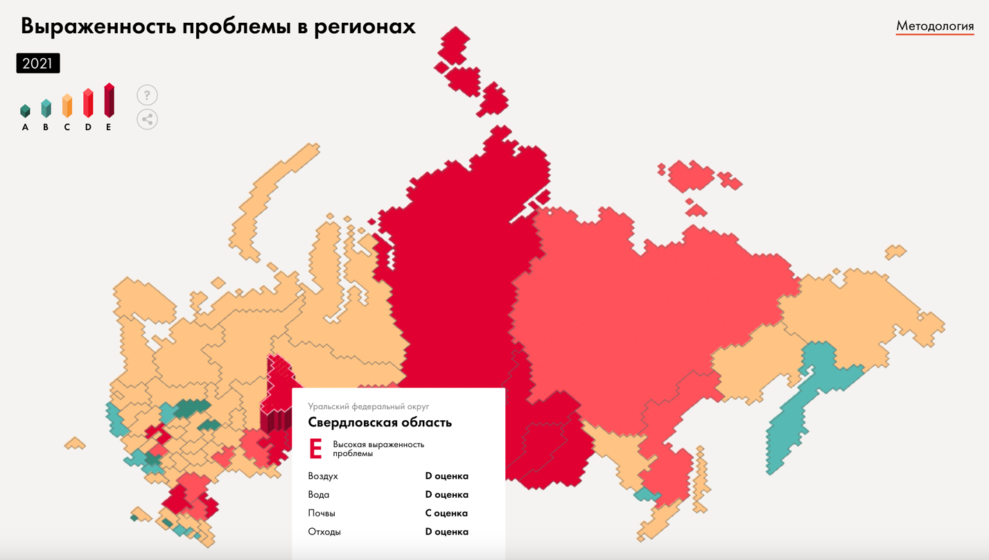
Interactive dashboard at the front page of the publication
The full research, complete with interactive infographics, an analytical report, and downloadable data: https://tochno.st/problems/ecology. There’s also a short summary article.
As a data journalist, I have undertaken several smaller research projects, primarily focusing on environmental issues. Here are a few examples of my work related to wildfires: an interactive dashboard created in Tableau, an article published in Novaya Gazeta, and research conducted for Tochno.st.

Fundraising for Leukemia Foundation
As a fundraiser for the Leukemia Foundation, I have raised over €1,000,000 in the past 1.5 years for people fighting against blood cancer. The current monthly numbers show an increase of 212% compared to the year of 2021, I started in.
As proof of my successful fundraising efforts, I can provide you with some of our fundraising and report pages, since our dashboards with numbers are private:
- ‘You’ve already helped’ page on the foundation website;
- Fundraising page on dobro.mail.ru;
- Foundation page on Global Giving;
- Foundation page on Nuzhna Pomosch;
- One of our current campaigns on miloserdie.ru.

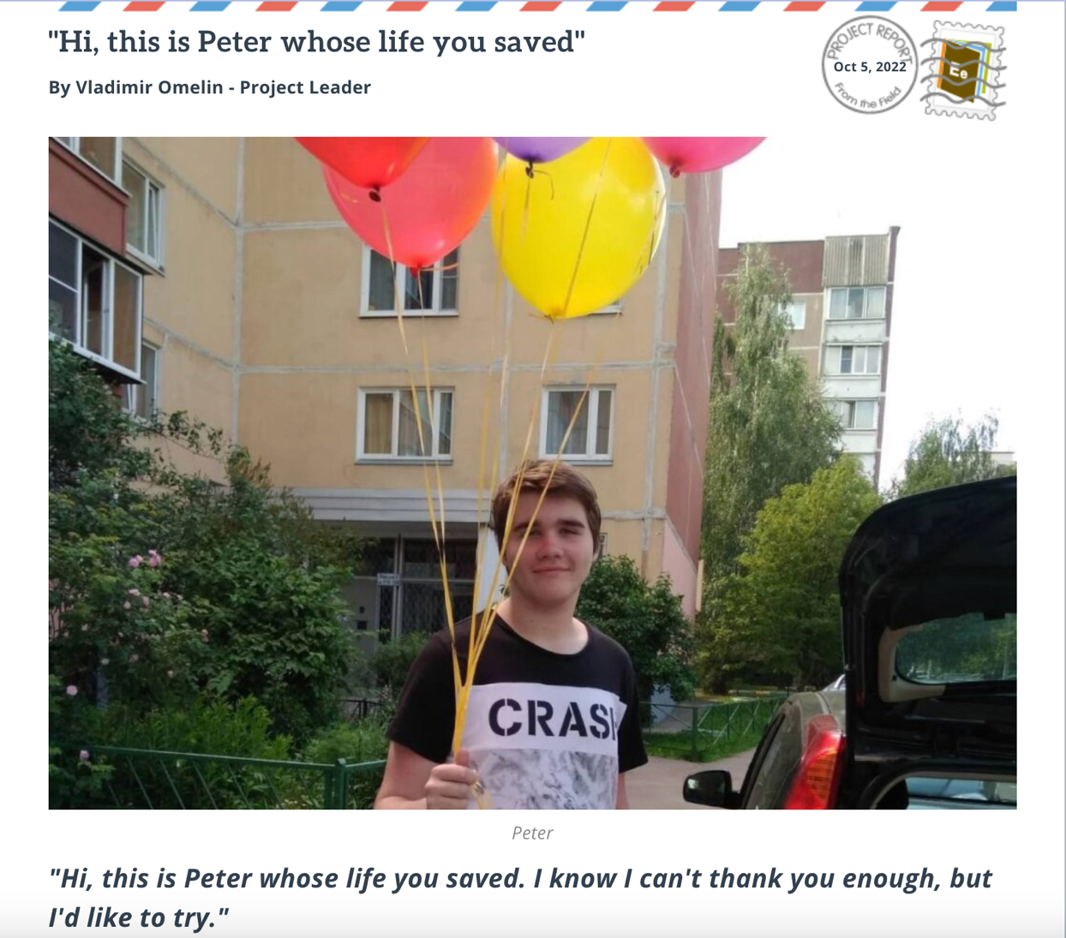
One of my project reports on Global Giving

Forma Uchastia, a project providing psychological support to forced emigrants
For the past 3.5 years, I have been studying gestalt therapy at the Moscow Institute of Gestalt Therapy and Psychodrama. In March 2022, in a period of widespread panic, I began offering free consultations as a way to contribute to society.
A year later, in Vilnius, I collaborated with another psychologist and an EHU student Egor Burtsev to launch the 'Forma Uchastia' project, which aims to provide psychological support to people who have been forced to leave countries.
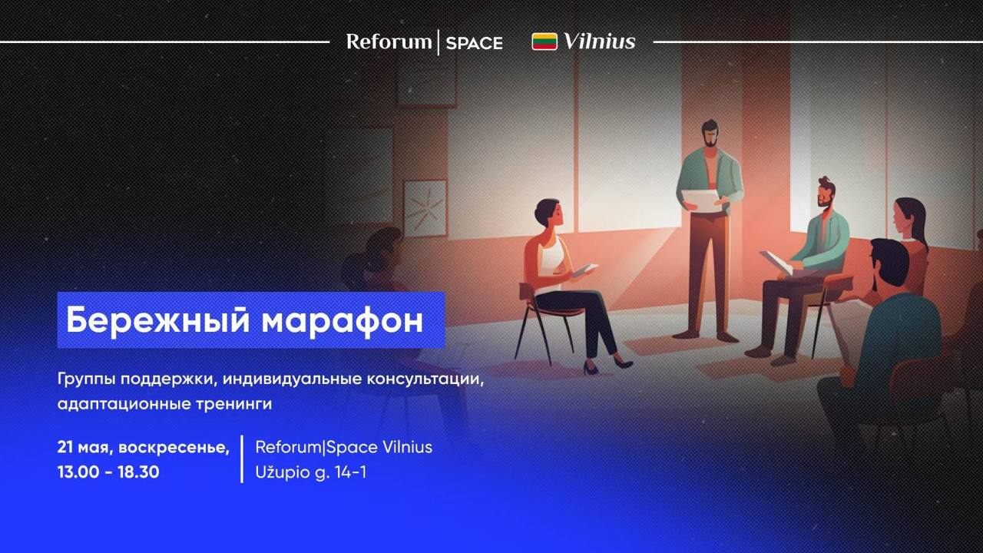
Our conference invitation

We’re just getting started, but we have already held a conference on the psychology of adaptation, we’re providing psychological support, and preparing to launch research on the psychology of forced emigration.

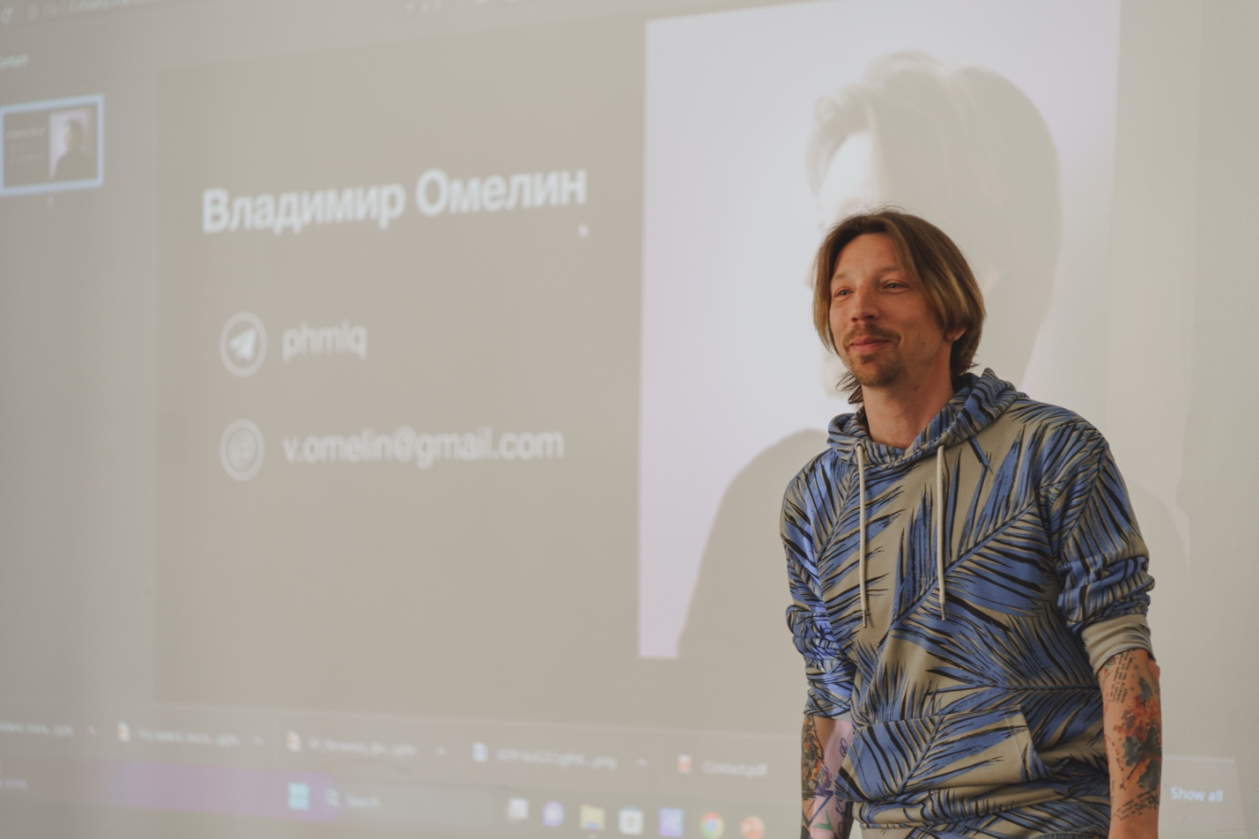 After my speech at the conference

Wildlife and nature conservation projects
As you can see in my Creative Works file, I have been involved in various wildlife projects, including the ‘Sockeye Salmon. Red Fish’ award winning documentary, ‘Pro Les’ independent media, and wildlife photo contests. As a project manager and a chief editor, I launched several websites for nature reserves, such as Pasvik, Kytalyk, and others.
These projects were never just about websites, films, stories, or photos to me. They were my way of contributing to addressing environmental issues and promoting nature conservation. I’m proud of these projects and creative works, whether I participated in them or created them entirely on my own.
Participating in these projects required significant effort, dedication, and courage. Once I found myself face-to-face with this bear. He ran towards me, seemingly ready to engage in a fight. However, against all odds, there was no fight. The bear went on its way, and I went on mine.

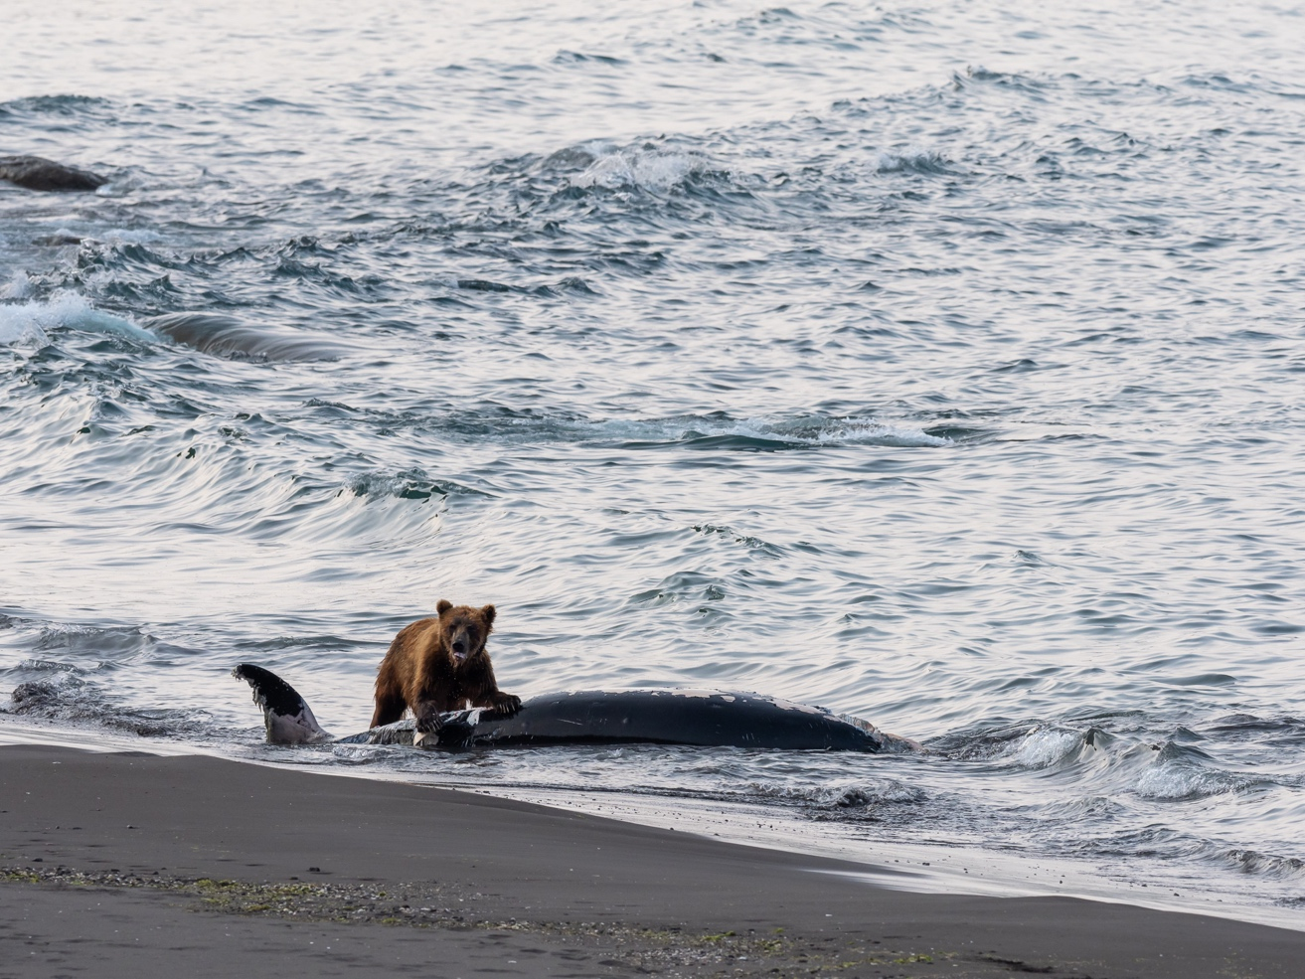

15+ years of event, media operations, IT, and construction project management
Before switching to NGO and socially impactful projects in late 2018, I had a long and successful career in event and media operations management, IT, and even construction projects before that.
I delivered infrastructure and congress services for many large events, such as SPIEF, Open Innovations Forum, the International Anti-Corruption Conference, and the Forum 'Russia — Latin America' that took place in Uruguay, among others. Although organizing these events, as well as building a plant producing car seat components or creating office networks for 100+ workstations from scratch, may not seem to me like something to be proud of now, they were still years of hard work, stress, growth, and various management challenges.
As a media operations manager, I worked for the Sochi 2014 Olympic Games, IIHF Junior Championship, and most importantly, I delivered media accreditation, media services, and media information for the biggest sport event in the world — the FIFA World Cup — as well as many other FIFA events, such as the Confederations Cup, official draws, and more. I was part of a core team of five people in media operations, and our work was recognized as the best press facilities of the year, surpassing even the Olympic Games and Wimbledon.
Throughout these years, I received many letters of gratitude and certificates of recognition from numerous organizations, although I didn't bring most of them to Vilnius. Fortunately, I did bring this one.


