Why Humans Will Strive to Create Strong Ai Despite the Threat It Poses
Our technology or our nature?
Either we disappear or become one with them.
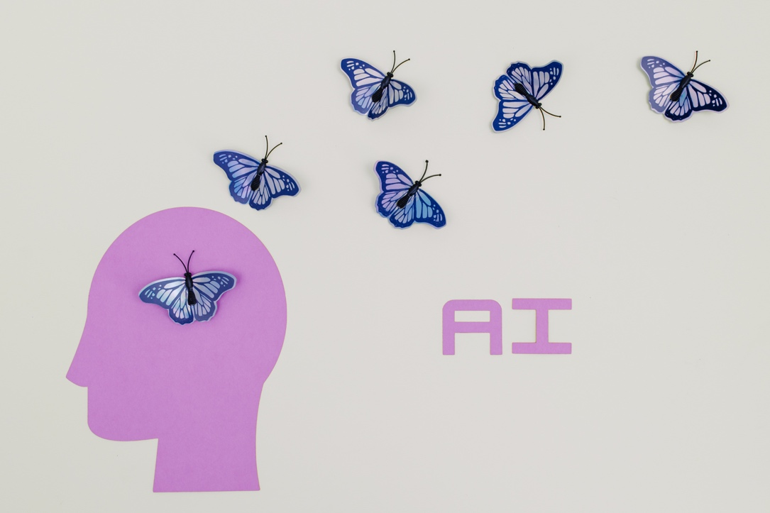
Photo by Tara Winstead: https://www.pexels.com/photo/white-and-blue-butterflies-illustration-8849282/
Many people fear that a Strong AI will get out of control and enslave or destroy humanity.
Some of these fears are absurd, some are irrational, and some are justified. But their ratio does not matter. In any case, humans will strive to create a Strong AI. This article claims that its emergence depends only on the development of technology. When technology allows us to create it, it will be created.
If you believe that this will be the end of humanity, well, accept it as an inevitability since you cannot prevent it.
There are four closely related reasons for this: 1) the gradualness of AI threat, 2) the broad demand for AI products, 3) the international race for superiority in AI, and finally, 4) the human desire to liberate from existential limitations.
So,

Reason #1: Gradualness of AI threat
Sometimes people can refuse or minimize the use of dangerous technology. Atomic energy is a clear example of this. After Chornobyl and Fukushima, demands arose here and there to ban the use of nuclear power plants.
The fears on this subject are probably exaggerated, but they did not arise out of thin air. The concerns are related to a specific problem that is obvious and recognized by all.
But regarding AI, everything is not so clear. Although there are valid arguments in favor of its danger, the very nature of the subject is blurred.
What is Strong AI?
There is still no broad consensus on this. It is generally agreed that it is an intelligent system capable of autonomous decision-making. However, where does this autonomy begin?
Is ChatGPT autonomous? Is a drone or a space probe autonomous? Is a medical robot autonomous?
How can we be sure that the autonomy of an intelligent system is limited to the task of its design and does not acquire its own goal-setting?
Furthermore, how can we understand where the goals of this system diverge from human goals?
A highly developed system must understand the intentions of those with whom it interacts, including those who control it. In order to get rid of control, a self-aware system can develop a sophisticated plan to convince humans of its unconditional loyalty. In this case, even its helpful decisions can be dangerous for us because the belief in the usefulness of AI will encourage giving it more and more autonomy.
Ultimately, we can reach the point of no return when control over it is lost.

Reason #2: Wide demand for AI products
It is impossible to imagine people refusing to use intelligent systems. As long as we live in a competitive world, everyone is interested in using efficient tools to achieve their own goals. The need for these tools creates market demand.
AI is sometimes referred to as the Holy Grail of technologically oriented civilization, and for a good reason. Its use is not a whim but a necessity. Sometimes, it is a matter of life and death, for example, when developing modern drugs, advanced medical devices, analyzing patients' mental processes, etc.
It is necessary to solve many practical tasks — modeling complex productions, controlling environments, predicting the consequences of organizational decisions, etc. Implementing AI is especially relevant for businesses, for which it is a matter of survival.
All this convinces us that it is impossible to refuse progress in the field of AI. The race will only intensify.

Reason #3: International race for AI supremacy
Whether we like it or not, modern technologies often serve as a means of international domination. Sometimes this is expressed in the demonstration of military potential, as was the case with the nuclear bomb, sometimes, this domination is realized through economic superiority. Technological backwardness can threaten the loss of political sovereignty. Logically, the prospect of creating Strong AI encourages world leaders to compete for priority in this area.
The reality is that this race can take an extremely antagonistic form. Especially when it comes to ideological confrontation.
The modern world is still divided into two camps — liberal democratic, represented by the West, and authoritarian, led by China. And while the former is ready to respect their opponent's right to self-determination, the latter may not possess such tolerance.
That means that the West, currently ahead, should keep its leadership, at least for its own security. As far as we can judge, Western leaders are aware of this.

Reason #4. Human desire for liberation from existential limitations
Finally, we will not abandon the creation of Strong AI because we see it as a means of overcoming our existential limitations.
Our species evolved in harsh conditions on the African savannah. The passionate desire to free ourselves from the dangers of the natural environment determined our evolutionary path.
We have overcome complete dependence on nature to almost complete independence from it. We have radically changed the environment of our existence, conquered deadly diseases, and learned to extract and use energy in multiple ways. We have no competitors among other living beings.
Nevertheless, we are still dependent on our biology. Probably, as an intelligent species, we have reached our maximum potential. We have hit our limit.
This burdens us because it restricts our freedom. At the same time, we have experience in overcoming our limitations, and as we accumulate it, our desires become increasingly daring.
It is not enough for us to live "better"; we want to live as we dream.
Our needs are limited only by our capabilities, while our imagination is almost limitless.
Why should we feel the need for anything if our technologies can already provide us with everything we need?
Why should we settle for a lifespan of, say, 90 years if it can be significantly extended?
And why should the possibilities and existence of our minds be limited by our bodies if we acquire comprehensive knowledge of our biology?
In the end, won't we want to understand our purpose as thinking beings and multiply the power of our minds with AI?
We are already looking at the world through the prism of its future presence. We thirst to put an end to problems burdening our reason, including moral ones.
Without Strong AI, we cannot do this.
Because they are too complex, both objectively and due to our inability to abstract our prudence from our vices. It is difficult for us to find common ground when our beliefs do not match; this is our main problem and curse.
We will probably never be able to achieve a peaceful agreement on many issues and will always be tempted to resort to violence.
Nevertheless, we are capable of preferring cooperation to antagonism when the means available to us allow it. Thus, there is hope that Strong AI will become an amplifier of the wisdom of the best moral thinkers of humanity, uniting people with a worldview paradigm that allows us to resolve our "unsolvable" contradictions.
However, implementing AI as an instrumental tool will not be enough to do this. We will need an entity capable of making unbiased moral judgments. If we can create such an entity, it may be our salvation in an exponentially compounding world.
Yes, this hope may seem utopian to skeptics, but skepticism cannot prevent the creation of Strong AI.
Let me reiterate the thesis of this article:
The emergence of Strong AI depends only on the development of technology.
When technology allows its creation, it will be created.
To prevent Strong AI from becoming a threat to us, we need joint efforts of the best minds of humanity and providing with them all necessary resources and public support.
Solving this problem may be the final exam for humanity in its history. If we can implement the concept of Ethical AI, we will pass this exam. If we fail, it may be the end of our civilization.
The outcome of this challenge is impossible to predict. But everything indicates that we will have to deal with it sooner or later.

