Why the Super-Rich Want Inequality, Not Just Wealth, and Why They Will Crave It More and More Until Doomsday
Exploring the psychology of the super-rich and their deepest fears fueled by neoliberal ideology.
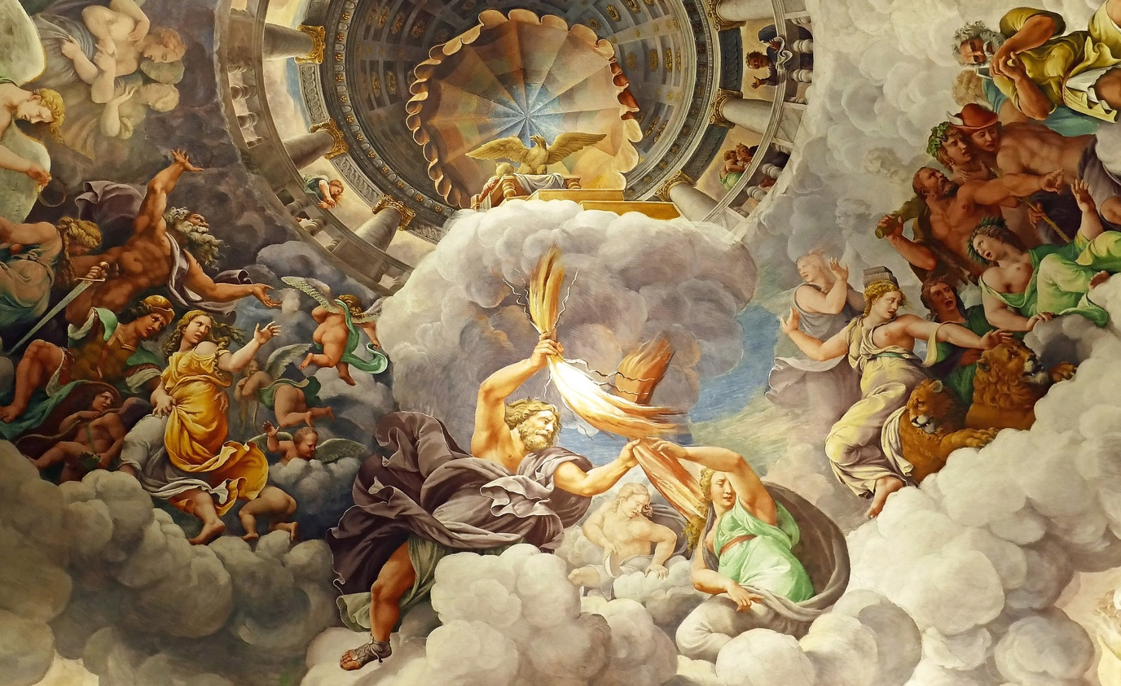
Image by Angelika from Pixabay

***
And yet, why do they need so much wealth?
Why all these excesses?
What is this, if not madness — all these palaces, yachts, super-jets, ridiculously expensive accessories, and other gaudy shit?
And why won't they ever stop? Is it pathological greed or something else?
It is indeed greed, but not just that. The drive is not so much towards wealth but towards inequality. It must be as bigger as possible. Justifying, fueling, and amplifying that inequality, the super-rich try to convince themselves that, unlike ordinary people, they will never leave this world. The world they cling to with a bulldog grip.

***
Humans cannot dwell on the thought of their death. To remain functional, they need their consciousness to bypass this unacceptable fact. This problem is studied under Terror Management Theory (TMT) in psychology. Research has shown that a crucial factor in this issue is the state of self-esteem, which can be both explicit and subconscious. Contemplating one's mortality reduces explicit self-esteem, causing discomfort, anxiety, and depression. In response, the individual unconsciously seeks ways to boost that indicator.
Surely, everyone can recall some event in life that instantly raises self-esteem. We feel a surge of energy, pleasure, even euphoria, and a desire to build upon that success. All previous misfortunes fade or are entirely forgotten at that moment. We feel at the peak of our potential.
And when such moments occur, we forget about our finitude. Death retreats to the recesses of our consciousness. It is experienced as a relief from a heavy burden, and we want to remain in this state of freedom and omnipotence for as long as possible.
The super-rich crave this, just like everyone else. But objectively, it is easier for them to attain. After all, self-esteem is measured by the difference between what the individual possesses and what others around them possess. Inequality plays a critically vital role here.

***
Inequality is not just about income and rights. It is a dividing line between non-existence and existence representing a gap of alienation between social classes. On one side of inequality are ordinary people; on the other — the super-rich. The wider it is, the farther the latter feel themselves from death.
They feel this way because they have an abundance of what ordinary people cannot obtain in a million years. No wonder they strive to deepen and perpetuate this inequality, pushing it to the extreme. They want it to be as pronounced as their immense wealth but with an opposite sign.
Super-inequality is detrimental to regular people but beneficial to those obsessed with the desire to feel superior to others. On one end, it creates an illusion of control over circumstances that no one can genuinely control. On the other, it manufactures, multiplies, and exacerbates these circumstances.
When the children of ordinary people die from cancer because their parents cannot afford their treatment, it proves the incapacity of these people to control matters of life and death. Death is not just real for them — it can knock on their doors anytime.
When a person loses their home due to a nationwide scam orchestrated by the super-rich, for the latter, it is not a reason for remorse but another justification for maintaining and increasing super-inequality.
In this regard, there is a motivating logic for the super-rich. Because such misfortunes demonstrate that people, in their natural, non-super-rich state, are mere playthings in the hands of circumstances, puppets of fate.
The power to keep people in this state allows the super-rich to believe in their existential exceptionalism.
The necessity for such circumstances is an essential part of the worldview of the super-rich. It compels their ego, driven off the rails, to initiate insane ventures, resulting in widespread social disasters.
They don't despair over those disasters because they know they will consistently profit, deceiving people unaware of what happens behind the scenes. And suppose these people try to expose them. In that case, the super-rich have armies of highly-paid lawyers, endless financial resources, cronies in the highest-power echelons, and a propaganda machine that suppresses any glimmer of reason.
After all this, how could the super-rich not consider themselves above people?

***
Thus, the wealthier the super-rich become, the more opportunities they have to make the lives of others difficult, and the easier it is for them to convince themselves that they can control what ordinary people are powerless against. That fills them with a sense of invincible power and disconnects them from sympathy towards people who have fallen into misfortune.
Therefore, super-inequality becomes their drug; the further they go, the larger dope they require.
And they know how to obtain this drug. Resourceful and relentlessly sniffing out contraband trails, their minds are capable of wonders of inventiveness. Entire nations go bankrupt, millions become homeless, fall into poverty and depression, some end their lives by suicide or go insane, destinies are ruined, and society disintegrates into hostile tribes. All of this is driven by a feverish thirst to grab as much of the material world as possible, even if it means pushing this world into hell:
— Politicians desperately attempt to discredit each other, fanning bestial hatred towards their opponents.
— Silicon moguls pump teenagers with digital opiates, sacrificing the future of their nation in the name of personal super-enrichment.
— Corporate leaders, from dawn to dusk, turn their employees into profit-generating robots for the benefit of the ruling caste of the company...
All in the illusory hope of buying their way out of the inevitable fate for every human being.
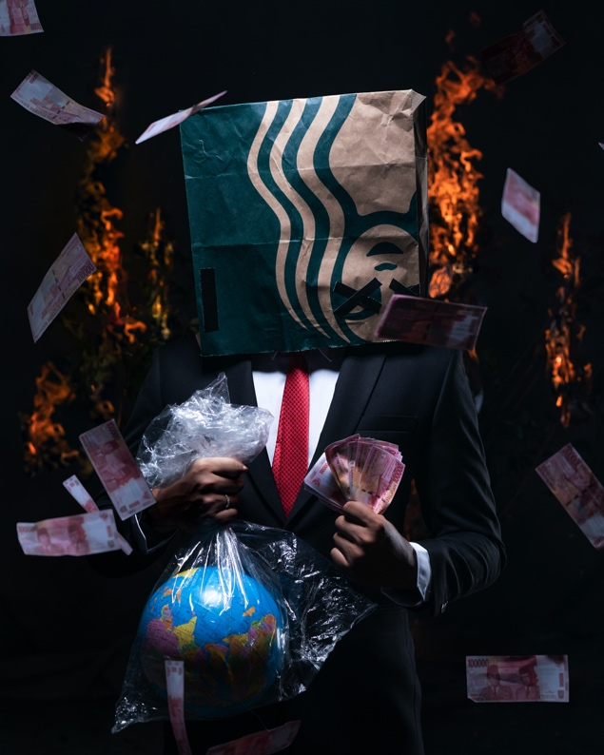

***
It's no wonder that the super-rich despise those who challenge their cosmic exceptionalism. Elon Musk demonstrated this better than anyone with his infamous tweet about the "pedo guy." And it's understandable: without the assurance of their omnipotence, the super-rich feel a growing existential anxiety. Hence, they push ordinary people away from them as far as possible, as if afraid to catch the virus of non-exclusivity. Hence, the fortress-like walls around mansions the size of airports, electronic locks on every window leaf, surveillance cameras in every cleft, and armed guards on every corner of the territory they marked as their own.
Margaret Thatcher once honestly expressed her class's attitude toward ordinary citizens:
Nowadays there really is no primary poverty left in this country. In Western countries we are left with the problems which aren't poverty. All right, there may be poverty because people don't know how to budget, don't know how to spend their earnings, but now you are left with the really hard fundamental character—personality defect.
You got it right: if you feel poor, it means you are defective. Because it's not up to you to decide what it means to be poor. If you think being poor means not having financial security, then something is definitely wrong with your thinking. If you don't find justification for the constant redistribution of the ever-increasing national wealth in one direction, there's something seriously wrong with you.
In all seriousness, they genuinely believe and expect you shouldn't have any other opinion.
...No, wealth isn't the true goal of the super-rich. The goal is super-inequality.
It's the condition of their super-richness, not its consequence. The super-rich use super-inequality to affirm their metaphysical exceptionalism.

***
Super-inequality is not just unjust and degrading. It's deadly dangerous for society as a whole. It corrupts the mind, erodes morals, and devalues human dignity.
It creates a vicious cycle of societal degradation. Political corruption becomes more blatant, justice is trampled upon, and lies and hypocrisy dominate public discourse. People get sucked into the abyss of nihilism or repressive ideologies.
Eventually, people stop trusting anything other than power. Violence becomes the only means of conflict resolution.

***
So, what can be done about it?
We need to redefine the problem in the public consciousness. Super-inequality should not be perceived as an unpleasant but inevitable and acceptable feature of the capitalist economic system. Instead, it should be recognized as an implicit goal of any capitalist due to the nature of human beings.
It does not suggest that every capitalist is corrupt or that representatives of other classes are less corrupt. It means that super-inequality is a guaranteed consequence of capitalism left to its own devices. If inequality becomes super-inequality and keeps growing, the system should be acknowledged as tolerant of evil.
That means that expediency of a just societal system should be based not on economic efficiency but on the ability to liberate its citizens from need. Economic efficiency does not guarantee justice or societal stability, whereas it should primarily serve to achieve these goals.
Changing systemic priorities does not imply a decrease in economic efficiency. Economic efficiency remains the prerogative of businesses and their ultimate goal, and they retain the exclusive right to choose paths to achieve it. At the same time, the business energy is redirected from a destructive path for human society to a constructive one. Belief in a just societal structure unleashes the creative potential of people, promotes social cohesion, and fills their hearts with pride for their community and nation.
Who among sane people wouldn't want that?
And this is by no means a utopia. The capitalist system operated this way for several post-war decades until the conservative turn in domestic policy occurred in the West with the rise of M. Thatcher to power in the UK. It marked the beginning of the era of neoliberalism, the contradictions of which are not only evident but glaringly obvious.

***
Defenders of the current status quo will fight tooth and nail, arguing that abandoning it will lead to catastrophe. But don't take their word for it. We are already witnessing the consequences of the creeping catastrophe; if nothing changes, it will only worsen.
The rhetoric of neoliberals is driven by their desire to preserve the distorted power dynamics between society and the capitalist system. In this system, society does not control the production of material values; instead, it exploits society to bestow privileges upon those who wield its reins.
The gatekeepers of this system will vehemently argue that there is no alternative, that a shift from capitalist values to humanistic ones would lead to "socialism." But this is yet another lie. It relies on the widespread ignorance of many people about the recent history of their own society (for a deeper dive into this matter, I recommend Thomas Piketty's well-known work, "Capital and Ideology").
The period of its greatest prosperity, known as Les Trente Glorieuses (The Glorious Thirty), occurred before the beginning of the neoliberal era. These were years of rapid economic growth and the highest purchasing power for the population. Naturally, inequality and wealth concentration were at their lowest during that period. This era is more closely associated with Western Europe, while the United States also experienced its "Golden Age" of socially responsible capitalism, known as the Great Society.
Reactionary forces, mainly right-wingers and conservatives, did everything they could to bring back the days of unregulated capitalism. They managed to hide its anti-human essence behind the appealing brand of “neoliberalism”. It must be acknowledged that it was a masterful move. The word "neoliberalism" instantly evokes "liberty," a concept that Western society is founded upon, but in reality, there is no genuine connection here:
Neoliberalism is an ideological justification for a system that perpetuates super-inequality. It does not solve any societal problems, whether it's healthcare, education, gender equality, LGBTQ+ rights, or fighting racism.
Adherents of neoliberalism use these labels to divert attention from the fraudulent schemes of corrupt elites. They inflate any disagreements among citizens and pit them against each other while continuing their dirty dealings under the guise of addressing these issues. In fact, they have a vested interest in perpetuating the existence of these problems at the level that suits their purposes.

***
So, in reality, neoliberalism leads to unfreedom as it promotes the merging of interests between the ruling class and capitalist monopolies. It excludes citizens from the political process, limiting their choices to representatives from the same corrupt ruling class.
We all must clearly understand the chain of links in this cleverly disguised evil of late neoliberalism:
- Irrational refusal to acknowledge shared human destiny
- Pursuit of this goal through the imposition of super-inequality
- Normalization of super-inequality through political corruption
- Elimination of civil society
- Denial of freedom and human dignity to people not belonging to the privileged caste ■
Responsible citizens must break this vicious cycle. To do so, they have to: 1) realize the fundamental motives behind the actions of privileged elites and 2) spread this knowledge among those who care about their future, their children, friends, and loved ones.
Do not be fooled. Just remember that there were other times in the history of free society. Although we should not idealize them, we must clearly understand the fundamental difference between that society and the model being imposed on us now:
The agenda of that society was the prosperity of its citizens, progress, and justice, not the usurpation of power and wealth by a narrow-privileged layer.
We must rediscover this society anew. And it is possible through the solidarity of citizens, their demand for those responsible to fulfill their interests, and the determination to reject those who use the public system as their trough.
Please, think about this and share your awareness with those capable of critical thinking and thirst for change.
TBC.

Margaret Thatcher Foundation / Interview for Catholic Herald — https://www.margaretthatcher.org/document/103793

