But if Everything Will Work Without People, What Will They Be Needed For?
A quick look into our near future — utopian for some and dystopian for others

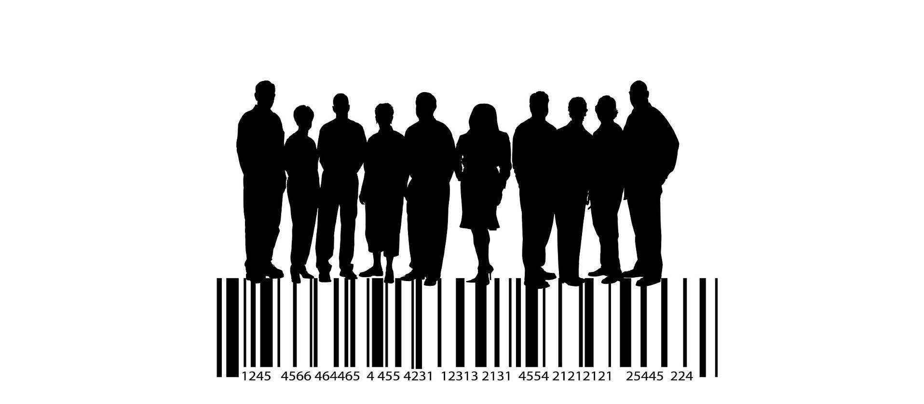
Image by Gerd Altmann from Pixabay

On the Eve of Total Automation
Modern society is rapidly approaching the beginning of the era of total automation. If anyone had any doubts that this time would come, the resonant advent of ChatGPT dispelled those doubts: it became evident that AI can replace humans in performing many tasks previously considered their prerogative.
The question is not so much when this will happen but rather how serious the consequences will be. Obviously, they will affect not only the employment structure and social security of people left without work. After all, if people no longer need to work in this Brave New World, what are they needed for?
This question may seem strange and even absurd, but it is fair. Not because any philosophical question is valid but because soon it may acquire a political character and certainly a moral urgency. For the first time in history, people may lose their value for the system that they created themselves.
I should clarify that I am not addressing the threat to human civilization from Strong AI (this is a separate topic). I mean the relationship between the majority of the population and those who have the privilege of making real decisions that determine the future of human civilization.
I want to draw the reader's attention precisely to this point: the ubiquitous implementation of automation will contribute to the disintegration of these two parts of society and the divergence of their interests.

Elites and people
Representatives of one of these parts possess political power and material resources that far exceed those of the average member of society. Representatives of the other part are, correspondingly, everyone else, those who are called "ordinary citizens," "regular people," etc. Simplifying the picture, let's just call them "elites" and "people." However, I will add that:
- Two classes can be distinguished among the elites — the ruling and the financial ones.
- The concept of "people" is also ambiguous. In a political meaning, some of them can be called "citizens,” while others are better described as "the masses.” It is not easy to draw this distinction regarding specific individuals, though.
The relationship between the elites and the masses has always been two-way. The elites needed the masses as a resource to realize their class interests: the ruling class — to maintain their privileged social position and the financial class — to generate wealth. Accordingly, the elites need the masses to organize their lives because, as Ortega y Gasset (1883-1955) expressed in his work The Revolt of the Masses, "...masses, by definition, neither should nor can direct their own personal existence, and still less rule society in general."
Civil society has always been a third party in these relationships. The elites, essentially, are hostile to it: the ruling class does not like civil society because it tries to prevent abuse of power and the financial class — because it insists on fair distribution of public wealth. Both of them would be better off without civil society.
As for the masses, although civil society is concerned about their well-being, they themselves are indifferent to such a society. They are not interested in anything except their everyday needs. The masses are inert and apolitical. According to Jean Baudrillard (1929-2007), they represent the "end of the social" (In the Shadow of the Silent Majorities).

End of market society
With the onset of the automation era, the relationship between the elites and the people will inevitably change. Predictive models of these changes suggest that there won't be any jobs left for most people in the future, which will trigger a cascade of other problems.
- The collapse of the labor market will cause a decline in the population's purchasing power.
- In the traditional sense, entrepreneurship will become impossible, and people will become entirely dependent on the state.
- Only two entities will remain in society capable of generating resources: the state (ruling class) and corporations (financial class).
The state, not being a manufacturer, but a regulator and distributor, will require corporations to transfer a particular portion of resources to it to fund a Universal Basic Income, providing the population with means of subsistence.
These changes will mean the end of a market economy and its replacement with a version of a planned economy. Until now, such an economy was considered unviable, but in this case, it will remain the only possible option, and its implementation under conditions of total automation and widespread adoption of AI may be successful.
Maybe the population's standard of living will not decrease too much (or not decrease at all), but their way of life will change completely. It will be an ultra-paternalistic society, as people will no longer have financial autonomy.
But will they still have autonomy in political decision-making?

Capitalism, Planned Economy, and Freedom
The protagonists of neoliberalism insist that only a capitalist society can be free. However, here they defend the interests of capitalists, not the ideals of freedom: China is a capitalist society, but there is no freedom there at all; Singapore is also a capitalist society and a totalitarian state, where the free press is practically banned, and those who disagree with the ruling class are persecuted.
However, capitalism not only fails to guarantee civil liberties. It does not even guarantee economic freedom. An unregulated capitalist society leads to the dominance of monopolies, i.e., to actual economic unfreedom. We live in a society that already resembles such a society.
It is Liberalism guarantees freedom, not capitalism. And, although many will never believe it, a free society may not be capitalist. To be liberal, it must guarantee political freedom rather than a certain economic order.
First and foremost, this concerns freedom of speech. Other freedoms are implemented by default as the absence of prohibitions, including the absence of a ban on free enterprise.
A planned economy can co-exist with quasi-entrepreneurship, i.e., earning income from the sale of one's own product. If we talk about intellectual or art products, such income can still be significant. However, in the era of total automation, mass production will turn from entrepreneurial activity into a social function.

Degradation of democracy and biopolitics
Thus, whether the future society will be free or totalitarian depends not on the economic system but on the realization of the rights and freedoms of people, i.e., on the existence of civil society.
Unfortunately, the ongoing degradation of Western democracy increasingly threatens such a society: the elite's desire to use the masses as a resource to achieve their own political goals encounters fewer and fewer obstacles, polarization has reached unprecedented levels, and there are very few independent media outlets left. These problems are particularly noticeable in the United States, where voters seem to have no choice but to choose between perennial figures of kind Biden or Trump.
And when real democracy eventually turns into a controlled one, the elites may make decisions about society's fate without asking its members' opinions. Political competition may remain, but changing political elites will only mean changing the faces in power, not changing the power's attitude toward people.
One decision of the elites could be a significant reduction in the population. There are no guarantees that the elites will prioritize humanistic considerations over purely practical ones. Only an effective power control system established by civil society can guarantee that. If there is no such a system, then in a world where elite privileges do not depend on the will of the people, the latter becomes a burden of the former.
Thus, the elites will try to get rid of those who have no practical value. The ruling class does not need to resort to suppression methods to do this. Population reduction can be adopted as an official demographic policy (biopolitics, to use the term coined by Michel Foucault (1926-1984)) and carried out using completely legal means with the support of the "democratic majority."
In the absence of independent media, achieving this support will be easy. The elites simply need to adopt a coordinated propaganda policy.

Limits to Growth
The idea of population reduction is not new to the West and is part of its socio-political discourse. It dates back at least to the work of English thinker Thomas Malthus (1766-1834), An Essay on the Principle of Population (1798). Malthus assumed that population growth usually exceeds the availability of food and other resources, leading to societal collapse (it should be noted that his work had a significant impact on C. Darwin and was one of the stimuli for his development of the Natural Selection theory).
Malthus's grim predictions did not come true, but they cannot be dismissed as groundless. In the early 1970s, an influential report by the so-called the Club of Rome entitled The Limits to Growth promoted a similar idea. It asserted that the infinite growth of the world's population and economy is impossible due to the Earth's limited resources. If consumption is not reduced, civilization will face catastrophe. This report gave rise to the concept of sustainability and the development of the UN's 17 Sustainable Development Goals (officially adopted in 2015).
Unsurprisingly, one of the means of preventing catastrophe that the Club of Rome report envisaged was stabilizing the Earth's population.
"Stabilization" is a vague term with no tangible boundary with "reduction." Again, this reduction can occur "naturally" — if mortality exceeds fertility.
Will this happen?
It is already happening — in the sense that birth rates in Western countries are constantly declining, and in some, they have fallen below mortality.
I do not claim that this results from implementing "biopolitics." However, whether Western governments will be interested in changing this trend in the future is a big question.
Currently, they express concern that a population decline could lead to a halt in economic growth, an increase in the proportion of elderly people, and a decrease in the number of working-age people. But tomorrow, completely different problems may become relevant. Everything can change very decisively.
It may suddenly turn out that a halt in growth, a disappearance of jobs, a decrease in the standard of living, or its duration is not a problem. The main problem is the overpopulation. And this will not be a problem of the future, but of the present. It will become clear that resources are becoming too scarce, that having more than one child is socially irresponsible, and that it is better not to have children at all.
There is no doubt that soon after such an agenda is announced, a mass of people will firmly believe that it is true.

Choosing the Future
What I will say next may seem quite cynical to some readers. But I simply want to honestly express my opinion about human nature, which, I would note, is not different from the views of many well-known thinkers.
So, whose future we are talking about?
Earlier, I noted that people can be either members of civil society or the masses. The masses have no future and cannot have one because they do not want to take responsibility for it.
And the masses will probably not be needed in the future, as they will lose their only social function — to be expendable material for the elites.
Throughout history, elites have been concerned about what to do with the masses when they could not use them. In Rome, masses were given bread and circuses. That completely satisfied their material, spiritual, and aesthetic needs. The Romans understood the psychology of the masses well.
Contemporary elites, equipped with the latest technology, of course, understand the essence of the masses no worse and treat them accordingly. They will surely find some appropriate entertainment for them. Zuckerberg's Metaverse is a great way to dispose of the masses, so to speak, TikTok on steroids. It may not be possible to implement this venture in the intended form soon, but eventually, this task is technically feasible.
And this will be precisely what the masses do need. Finding themselves in a fictional world where they can freely experience any sensations is their paradise. They will happily spend their entire lives there until they gradually become extinct. For the elites, this will be the optimal solution.
Should anyone prevent this?
Simple humanity requires us to say "yes." Whatever differences there may be between people, we are all representatives of one species, and our similarities are much greater. And as long as we consider ourselves human, our paramount dignity is not intelligence, not even the ability to create, but empathу, compassion, and readiness to help another human being.
On the other hand, it would be a delusion to attribute some dignity to those who do not have it. If a person chooses to spend their life on meaningless entertainment, no matter what alternatives are offered, that will be their choice. It would be arrogance to impose on them an inauthentic life scenario.
And therefore, in this new world, the main task for people will probably be to ensure that everyone achieves genuinely free and conscious choices. This choice must be the result of access to all existing options.
Undoubtedly, this choice will be very different for different people. Someone will engage in the colonization of Mars, and someone will immerse themselves in the M̵a̵t̵r̵i̵x̵ Metaverse and consciously remain there forever.
Let us hope that the people of the future society will have enough wisdom to respect, or at least accept with humility, any of these choices.

