- Winning the preliminary round in Public Speaking Competition in 2017
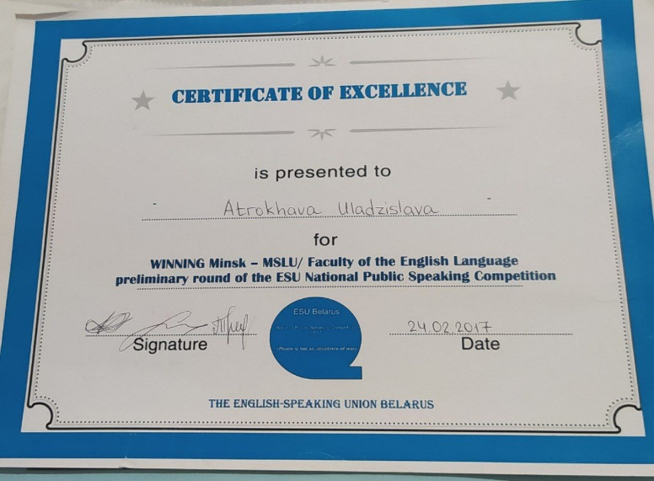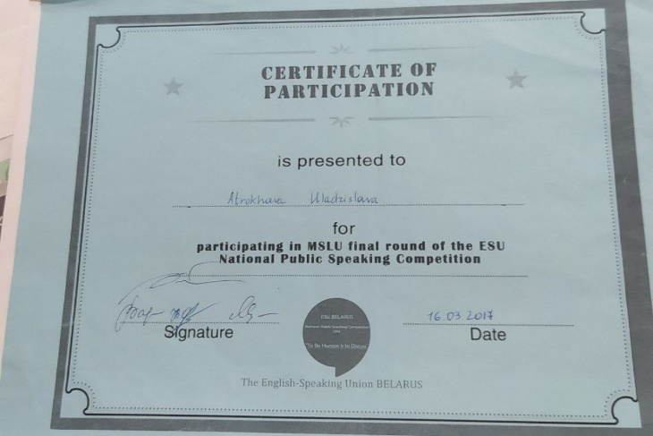
Participation in the Public Speaking Competition in 2017 on the topic "Peace is not the absence of war" was a transformative experience that transcended mere words and rhetoric. As I stood before the audience, the weight of those profound words settled upon me like a mantle of responsibility, urging me to convey a message that went beyond the conventional definitions of tranquility.

With each word spoken, I sought to paint a vivid tapestry of understanding, illustrating that peace is not merely the absence of conflict but a state of harmony that emanates from within. The stage became a platform for me to weave together threads of empathy, compassion, and unity, inviting the audience to delve into the depths of their souls and contemplate the true essence of peace.

With each intonation and gesture, I endeavored to ignite a spark within the hearts of the listeners, inspiring them to become agents of change in a world yearning for harmony. The applause that followed was not merely a validation of my performance but a testament to the power of words to stir emotions and provoke introspection.
The essence of my work:
Building Peace in Our Hearts and Minds

"Set peace of mind as your highest goal and organize your life around it" - Brian Tracy.

Change is inevitable, yet many of us fear it. We often dream of making changes in our lives but struggle to take action. We postpone transformations, telling ourselves that we will start afresh on Monday or with the new year, only to find ourselves stuck in the same routine. We become comfortable with the familiar and resist stepping out of our comfort zones.
However, it is through small, seemingly insignificant decisions that our lives can change for the better. The common adage "If you want to change something, begin with yourself" holds true, but do we truly understand its significance? It is a question worth pondering.
The desire for world peace is universal. We envision a world free from problems, fears, and wars, where trust and mutual understanding prevail. While achieving a perfect world may be an idealistic notion, we can strive to make our world a better place. Each of us has the power to contribute to building a more peaceful society.
When we think of peace, we often focus on global issues, overlooking the fact that monumental achievements start with small steps. Each individual is a universe in themselves, and cultivating inner peace is the foundation for creating a harmonious world. When we are at peace within ourselves, we become more resilient to stress, our immune systems strengthen, and we perceive the world with greater optimism.
The question then arises: how do we build peace in our hearts and minds? It begins by identifying what inspires us and brings us joy. By connecting with our inner selves and finding solace in the beauty of life, we can cultivate a sense of peace that transcends external challenges. Listening to our hearts, free from societal influences, allows us to tap into our inner wisdom and connect with the universal essence of peace.
Therefore, our primary goal should be to "build peace inside you - and you will build peace around you." World peace and inner peace are intertwined, and as individuals, we play a crucial role in fostering a culture of harmony. Each step we take towards inner peace contributes to the collective journey towards a more peaceful world.
In conclusion, let us remember that building peace within ourselves is not just a personal endeavor; it is a vital step towards creating a more peaceful society. We are all interconnected pieces of the larger puzzle of peace, and by nurturing peace within our hearts and minds, we can positively impact the world around us.
- My personal growth in poetry
At a fairly young age, I became interested in poetry. At first my interest was only in reading similar works by other authors, but after a while I started to try to express my thoughts myself. My arsenal of poems includes both works in Russian and English. Here's a link to familiarize yourself with them:
Владислава Атрохова / Стихи.ру (stihi.ru)
Some of the poetry was selected in various categories on the publications’ website.
- IELTS teacher training workshop with British Council
In my perception of things, it's impossible to evolve by standing in one place. Since I worked mainly in the field of education as an English teacher, I considered it necessary for my professional growth to develop in another direction of language learning, going beyond the Belarusian format exams.



